finMr1™

fiTLAHTft Qfi 30362-0070 S3! PI

AC Controllers: Neffy’s Dirty Dozen, card-reader installations,  
the latest S&G electronic safe lock, transponder technology on the Mustang  
police locker boxes, pinning locks, legislative news,  
a priceless letter written by Lynus Yale and much more.

The Official Publication of ALOA—An International Association of Security Professionals

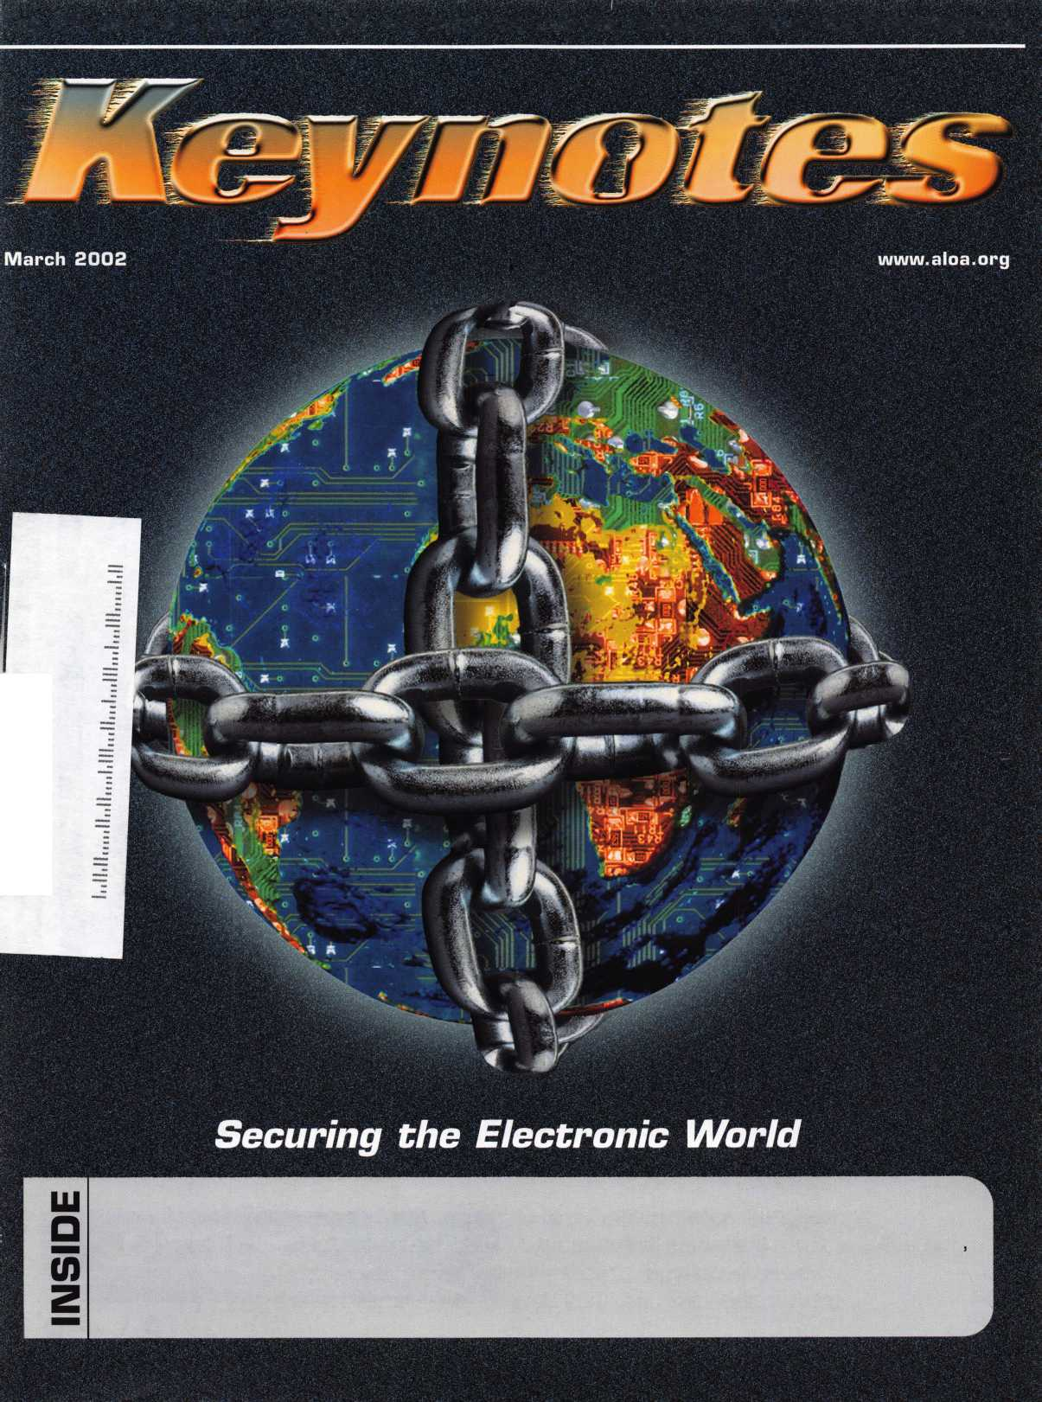

April 8-13 John Ascuaga's Nugget Resort • Reno

Nevada

reno, nevada

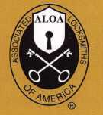

Participate in the only van and storefront contest that PAYS!

ALOA is now accepting photo entries for the all-new 2002 van and storefront contest. In reclaiming  
the old contest, we've made some great updates. Prizes will be given out to the top three winners,  
who will be announced on the show floor at ALOA 2002 in the Chicago suburb of Rosemont, IL.  
(Winners do not have to be present to claim prizes.)

All you have to do for your chance to win one of three great prizes is submit a printed picture of your

storefront or van (complete with contact information) to the following address: ALOA Van and Storefront Contest,  
3003 Live Oak St., Dallas, TX 75204. Or, simply e-mail a high-resolution photo in JPEG format (no files over  
3 megabytes will be accepted) to: [editor@aloa.org](mailto:editor@aloa.org). (Note: Make sure to write  
"ALOA Van and Storefront contest" in the subject header of the e-mail.) Good luck and  
may the best van win! (And the best shop front too!)

Entries accepted now through July 1, 2002.

Hurry now to be a part of the original ...

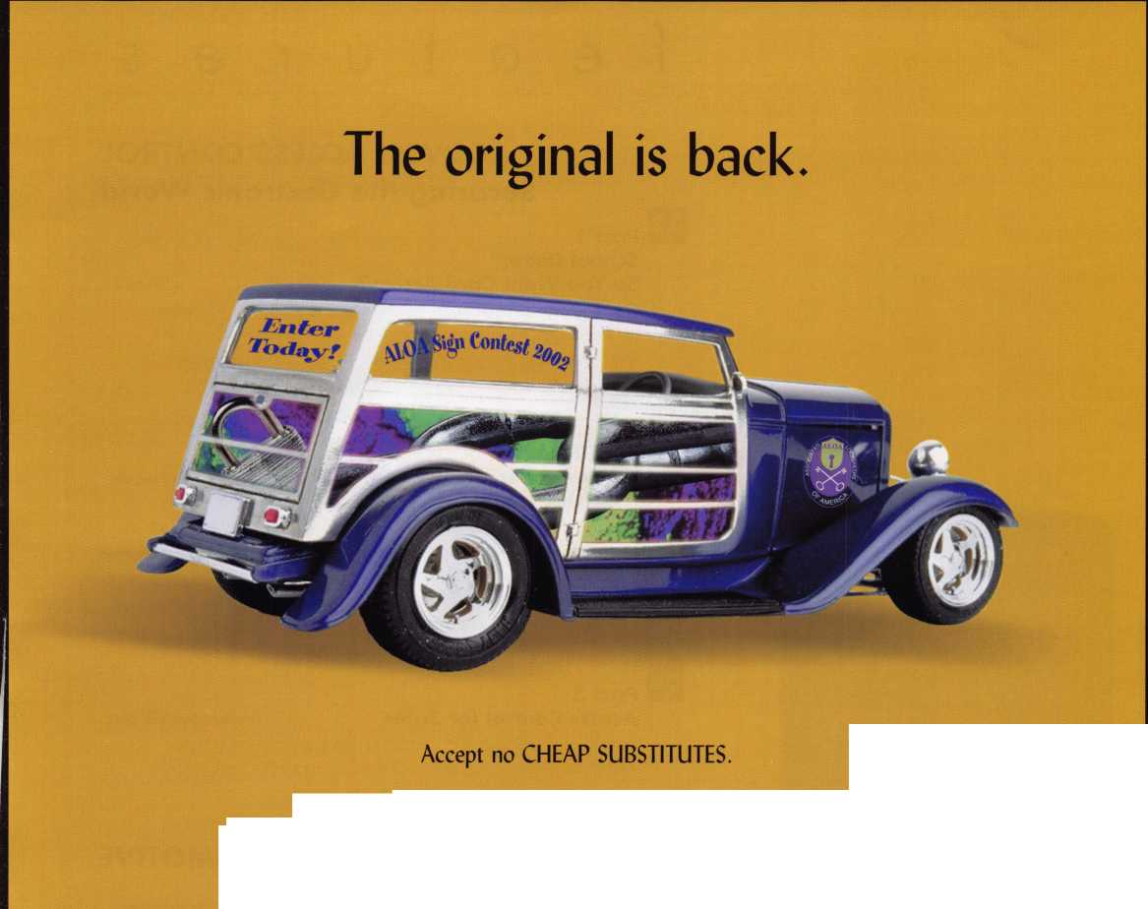

features

|  |  |  |
| --- | --- | --- |
| d | epartments |  |
| 4 | President's Journey |  |
| 6 | Applicants |  |
| 8 | Upcoming Events |  |
| 10 | Core |  |
| 38 | Legislative Update |  |
| 40 | Classifieds |  |
| 42 | Associate Member Listing |  |
| 44 | Back Page |  |
| L |  |  |

COVER: ACCESS CONTROL



Securing the Electronic World

Part 1

School Daze:

So You Want Card Access? By Don Seburg

Don Seburg still remembers how it all started back in 96, when he first began his quest to replace the existing key system at the Minnesota school district over which he directed security. Several twists and turns later, he solved the Riddle of the ISD Sphynx.

**16**

AC Controllers: Neffy's Dirty Dozen By Bill Neff, cml

Access control has been around a lot longer than most people realize. In the vast world of AC that has exploded since its hum­ble beginnings, information overload has caused us to second guess and even withdraw from the market. If you want the bot­tom line on what to look for in an AC controller unit, you need look no further than this article.



Part 3

Access Control for Safes

By Brian Costly, CML, CMST

The days of rolling a rock in front of the cave are long gone. And in its place comes an "evolution" of sorts - the new 6150 electonic safe lock from Sargent & Greenleaf.

**30**

AUTOMOTIVE

Mustang Transponder Tutorial By Jeff Trepanier, RL

Let auto whiz Jeff Trepanier, RL, walk you through all of the servic­ing steps for the latest installment of a modern classic: the often imitated but never duplicated Ford Mustang.

**20**

BASIC LOCKSMITHING

A Quarter for Your Thoughts:

Inside Tiffin's "Sentinel" Coin Lockers By Greg Perry, CML, CPS Ever wonder how a coin-operated locker works? Until recently, the author could only wonder. Then the phone rang and was learning on-the-fly once again.

**36**

HISTORY

An Original Linus Yale Letter Turns Up bya.j. Hoffman,cml When our antique locking guru heard about his chance at seeing an original letter written by Linus Yale, he jumped at the opportunity - and had some fascinating discoveries.

Visit

our we

bsite at [www.aloa](http://www.aloa)

o r g

Keynotes • March 2002

**executive**



Additional contact information for the ALOA Board and most Keynotes authors is available through "Locksmith Search"' on the ALOA Web site- [www.aloa.org](http://www.aloa.org) or by contacting the ALOA office at 3003 Live Oak Street; Dallas, TX 75204; (800)532-2562; FAX (214)827-1810; e-mail [aloa@aloa.org](mailto:aloa@aloa.org).

Editor

Jim DeSimone [editor@aloa.org](mailto:editor@aloa.org)

Technical Editor

David Lowell, CML, CMST [david@aloa.org](mailto:david@aloa.org)

Editorial Advisor

John D. Cannon, CML [jdcannon@worldnet.att.net](mailto:jdcannon@worldnet.att.net)

Art Director

Betty Henderson [betty@aloa.org](mailto:betty@aloa.org)

Advertising Sales e-mail: [adsales@aloa.org](mailto:adsales@aloa.org)

Executive Director

Charles W. Gibson, Jr., CAE [charlie@aloa.org](mailto:charlie@aloa.org)

Convention & Meetings Manager

Kelly Carr, CMP [kelly@aloa.org](mailto:kelly@aloa.org)

PRP/Education Manager

David Lowell, CML, CMST [david@aloa.org](mailto:david@aloa.org)

Operations/Membership Manager

Mary May [mary@aloa.org](mailto:mary@aloa.org)

Director of Information Technology

Randy McChristian [randy@aloa.org](mailto:randy@aloa.org)

Government Affairs Manager/

Chapters & Regional Associations Liaison

|  |  |
| --- | --- |
| Tim McMullen | [tim@aloa.org](mailto:tim@aloa.org) |
| Comptroller | Kathy J. Romo |
| Network Specialist | Greg Jackson |
| Membership Coordinator | Shelly Jett |
| Convention & Meetings Assistant Karen Lyons | |
| PRP/Education Coordinator | Ashley Manson |
| Accounting Coordinator | Kathy Stokes |
| Mail Room Coordinator | Dennis Henderson |
| Mike Oehlert, CPL, CPS  Randy Simpson, CML  Robert Stafford, CML  Dave Thielen, CML  Greg Perry, CML,CPS | Tom Seroogy  Charles Stephenson, CPS Dennis Watanabe, CML, CMST |

Contributors

Jerome Andrews, CML Paul Chandler, CRL Claire Cohen, CML Brian Costley, CML, CMST Ray D'Adamo, CML

Sal Dulcamaro, CML Billy Edwards, CML Dan Graffeo, CRL,CMST AJ. Hoffman, CML Jeff Nunberg, CML, CMST

Mission Statement: The Associated Locksmiths of America, Inc. is dedicated to enhancing the professionalism, education and ethics among locksmiths and those in related sectors of the physical security industry. With approximately 10,000 members in the United States, Canada and the freeworld, ALOA is poised to help members obtain the knowledge, the strength, and the confidence to perform their role in the physical security field with pride and dignity. But it is only through active involvement and participation that ALOA can fully achieve its potential—and can help members to achieve theirs.

Policies: Keynotes® is the official publication of the Associated Locksmiths of America, Inc. (ALOA). Keynotes® acts as a moderator without approving, disapproving, or guaranteeing the validity or accuracy of any data, claim, or opinion appearing under a byline or obtained or quoted from an acknowl­edged source. The opinions expressed by the authors do not necessarily reflect the official views of ALOA. Also, appearance of advertisements and new products or service information does not constitute an endorsement of products or services featured by the Association. The Association does not accept responsibility for the inaccuracy of any data, claim, or opinion appearing in this publication, due to typographical errors on the part of the authors, Association staff or its agents.

Editor's Note: This publication is designed to provide accurate and authoritative information in regard to the subject matter covered. It is provided and disseminated with the understanding that the publisher is not engaged in rendering legal or other professional services. If legal advice and other expert assistance is required, the services of a competent professional should be sought.

Authors' Payment: Payment for eligible submissions to Keynotes will be based on the following criteria: topic, time spent and past contributions. Authors who regularly submit to Keynotes® are generally paid a higher rate. The latter is especially true of authors who write to fit specific editorial needs and submit said copy by Keynotes® deadlines. As a general guideline: Average payment for a 750 word, business or 'light' technical article would be $200. Payment for a 1500 word article involving significantly higher time and research efforts would be $400.

Payment will not be offered for articles submitted by ALOA employees or members of the ALOA Board of Directors (unless material is of a technical nature), nor for articles submitted by a company that promote that company's products or services. ALOA reserves the right not to pay for articles sub­mitted by an individual(s) that promote a particular company's products or services.

Disclaimer: The Associated Locksmiths of America, Inc., (ALOA), reserves the right to refuse any article for any reason. Additionally, ALOA reserves the right to edit, amend or modify any article submitted for publication in order to preserve technical accuracy, clarity, fairness or grammatical cor­rectness. ALOA will make the best efforts to notify the author of any changes. The extent of ALOA's liability for any article or information contained therein will be a notice of correction or retraction in the next possible issue.

Keynotes® (ISSN 0277 0792) is published monthly except for the combined June/July issue by The Associated Locksmiths of America, Inc., 3003 Live Oak St., Dallas, TX 75204-6186. Telephone: (214) 827-1701; FAX (214) 827-1810; e-mail [aloa@aloa.org](mailto:aloa@aloa.org). Subscription rates for members—$15.00 per year. Second class postage paid at Dallas, Texas. POSTMASTER: Send address changes to: Keynotes, 3003 Live Oak St., Dallas, TX 75204-6186. © Copyright 1999, All rights reserved. No part of the contents may be reproduced or reprinted in any form without prior written permission of the publisher.

President

Randy Simpson, CML  
(713) 780-7026  
[president@aloa.org](mailto:president@aloa.org)

Secretary

John D. Cannon, CML  
(703) 9606413  
[jdcannon@worldnet.att.net](mailto:jdcannon@worldnet.att.net)

Directors/ Northeast

John C. Magee, III  
(856) 845-3434

Peter Sarailian, CRL  
(201) 947-6291  
[psaraiiian@yahoo.com](mailto:psaraiiian@yahoo.com)

William L. Young, CML

(610) 647-5042

Directors/ Southeast

Vincent Formon, CML, CPS

(901) 324-2910

Donald E. Rule, CML  
(601) 324-2658  
[rulecml@ebicom.net](mailto:rulecml@ebicom.net)

Directors/ North Central

Mark E. Blum, CML, CPS  
(517) 482-5809  
[mblum@arq.net](mailto:mblum@arq.net)

John Soderland, CML, CMST  
(414) 327-5625  
ncd i rector@a loa.org

Director/ South Central

Randy L. Simpson, CML

1. 780-7026

Directors/ Southwest

Gordon R. Racine, CML  
(719) 384-4707  
swdirector@aloa .org

Julie McCluney, CRL

1. 636-5652 swdirector@aloa .org

Director/ Northwest

Scott L. Henke, CRL, CPS  
(907) 248-3785  
[action@alaska.net](mailto:action@alaska.net)

Director, Associate Members

David F. Matthies  
(727) 541-5536  
d matth i es@southern lock. com

Trustees

johnj. Greenan, CML, CPS  
(773) 486.2030

Dallas Brooks  
(334) 826-8990

David M. Lowell, CML, CMST  
(800) 532-2562

Edwin Toepfer, RL  
(416)225-5589

Past Presidents

1999-2001 John Greenan, CML, CPS  
1997-1999 Dallas C. Brooks  
1995-1997 David Lowell, CML, CMST  
1993-1995 Breck Camp, CML  
1991-1993 Henry Printz, CML  
1989-1991 Evelyn Wersonick, CML, CPS:  
1987-1989 Leonard Passareilo, CPL  
1985-1987 Joe Jackman, CML  
1983-1985 Stanley Haney, CPL  
1981-1983 Louis LaGreco, CPL  
1979-1981 John Kerr, RL  
1977-1979 Clifford Cox, CML  
1974-1977 Charles Hetherington  
1972-1974 Gene Laughridge  
19701972 William Dutcher, RL  
1968-1970 Constant Maffey, RL  
1966-1968 Harold Edelstein, RL  
1964-1966 William Meacham  
1962-1964 Robert Rackliffe, CPL  
1960-1962 Edwin Toepfer, RL  
1956-1960 Ernest Johannesen

Keynotes • March 2002



Hello Members,

As we move into this new year, we are faced once again with the legislative challenges between ALOA and NBFAA. On many of the issues, we are on the same side and on oth­ers we are at opposite ends. ALOA will continue to defend its membership, 80 percent of whom do access control and CCTV, from licensing legislation that impedes their ability to work. The same battle is taking place between the entire low-voltage industry and electri­cal contractors, an issue that ALOA stands firmly with NBFAA. Don't get me wrong, we are strongly advocating licensing for the physical and electronic security industry, and wel­come ways that ALOA and NBFAA can work together like we did in Illinois and New Jer­sey. We passed a resolution last year to be more pro-active in licensing, making sure it takes place on our own terms.

After the events of September 11th, we see a growing interest in security. At the last ISC Show, which took place in New York before those tragic events, we already saw the move toward electronics. ALOA recognized that industry trend, and began a membership recruit­ment drive that focused on obtaining members who do a majority of their work in elec­tronic security. We have had a tremendous response, with new members up 35 percent over this time last year. This is where the industry is going, this is where our membership is going and this is where ALOA's efforts are going. To ensure that they are well educat­ed in the latest technology, ALOA is now offering 15 percent more classes in electronic security than we did last year.

As ALOA and NBFAA work on more and more projects together, I am confident that our two associations will solidify our relationship and continue to strive for what is best for the security industry overall. But we shall always look out for the interests of our members first and foremost.

Randy Simpson, CML

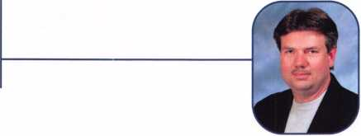

Keynotes • March 2002



***Visit our Website on  
www. stamcctv. com***

**THE COMPLETE**

**CCTV PROGRAM ON CD-ROM  
FOR STAFF TRAINING AND**

**PRODUCTIVITY ENHANCEMENT**

STAM **Insight** has been  
developed to enhance CCTV  
skills and productivity with  
many different uses.

® Productivity

**W** System Drawing Estimation **#** CCTV Training H CCTV Reference Hi Sales/Demo I# System Design **W** Staff Evaluation

CC7V Content

CCTV Calculators

Demonstration Tool

Estimation

Drawing

Internet Enabled

Pre-Test

Quizzes

Ho

**INFOMATE**

**WORKMATE**

**ULTIMATE**

**Sold in Over 50**

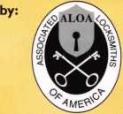

3003 Live Oak Street  
Dal las, Texas 75204

Name:

Job Title:

Organization: Address:

.Zip/Postcode, .e-mail

Fax: ( )

COPYRIGHT © 1996 Security Training and Marketing Pty Ltd. All rights reserved ACN 057 006 541

Country

Tel: ( )

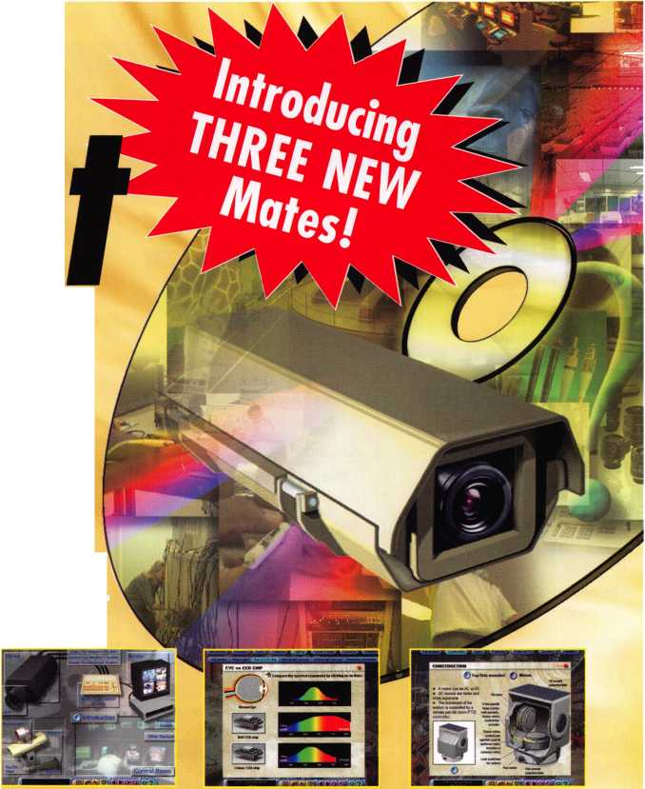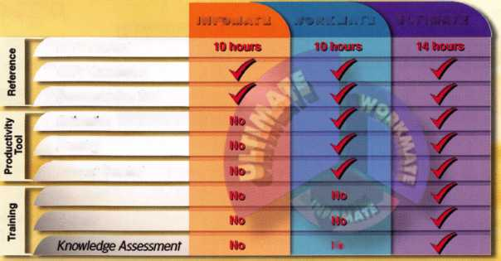

AL

FL

**applicants**

for membership

Auburn University

Thomas E. Cobb

Sponsor: John D. Brooks Sponsor: Marian E. Sagar



John T. Burgess

Sponsor: Donald H. Phillips CRL

Shane Knapp

Sponsor: James E. Lancaster CML

*KL*

Tempe

Brandon Cline

Sponsor: Phillip R. Cookman CRL

CA

Palm Desert

Robert Airrington

Ramona

Paul C. Burns Jr

Sonoma

Roger Bassett

Sponsor: Gloria Moravec

co

Fort Collins

Tyler S. Blanks

Sponsor: Raymond J. D'Adamo CML

Keystone

Juan Padilla

Sponsor: Dottie Riotto

CT

New London

Michael Holmes

DC

Washington

Donald Thomas

Lake Worth

Kevin D. Parker

Sponsor: Jim Jeffries CPS

Miami

Felix Ascona

Sponsor: Juan F. Pujol

Orlando

Elias DeHoyos

Sponsor: Larry L. Puckett

Wauchula

Woodrow L Quinones

Sponsor: John W. Soderland CML, CMST

GA

White

Travis T. Whatley

Sponsor: John C. Elliott Jr, CML, CPS

HI

Honolulu

Kyle Kim

IA

Urbandale

Dan Swift

IL

Champaign

David A. Crawford

Sponsor: Ira J. Bishop CRL

Chicago

Jimmy Rivera

Effingham

Terry L. Bierman

Sponsor: Floyd D. Barlow CRL

Elk Grove Village

Mark D. Gerhardt

Sponsor: John W. Soderland CML, CMST

Hoffman Estates

Michael Fallon

Melrose Park

Timothy P. Gerster

Sponsor: William T. Beranek

Steger

Dwayne E. Sass

IN

Anderson

David A. Walker

Argos

Debra Mersch

Kendallville

Willis D. Hecht

Sponsor: David P. Snyder Sr

Logansport

Ralph E. Greenwood

Wabash

Steve S. Hudson

Sponsor: John W. Boyer CML

Lexington

Andrew R. Dixon

MA

Fall River

Jonathan E. Costa

Sponsor: Michael O'Shaughnessey

Malden

Debra Romano

Sponsor: David M. Troiano

Natick

Steven Elman

Sponsor: David M. Troiano

Wilmington

Paul Agostino

Sponsor: David M. Troiano

MD

Baltimore

Simone L. Brown

Damascus

Christopher J. Snook

Fulton

Steven G. Smith

Silver Spring

Joseph R. Erdmann

Ml

Trufant

Carey E. Britton

Sponsor: Bradley J. Polega CRL

MN

Hector

William K. Teetzel

Sponsor: Robert C. Fortmann RL

Saint Paul

Ed McCabe

Sponsor: Lawrence M. Friedrichs CPL

Vadnais Heights

Brian Jeuts Timothy D. Stemig Jeremy D. Greeder

Vadnais Hts.

Rich Vangen

MS

Clinton

Marc Cerisier

MT

Big Arm

Ricky H. Webber

Sponsor: Todd E. Rasmussen CRL

Choteau

Eugene L. Cote'

Sponsor: Robert D. Breckenridge CRL

These applicants are scheduled for clearance as members of ALOA. The names are published for member review and comment within 30  
days of this Keynotes issue date, respectively, to ensure applicants meet standards of ALOA's Code of Ethics. Protests, if any, should be  
addressed to the Membership Department and must be signed. Active Membership applicants (a) have worked in the industry two or more  
years. Allied Membership (AL) applicants are not locksmiths, but work in a security-related field. Apprentice Membership (AP) applicants

have worked in the industry less than two years.

Keynotes • March 2002

**Charlotte**

Kirk D. Johnson

Sponsor: Pierre Burley

NH

**Plaistow**

Walter F. Toomey

Sponsor: David M. Troiano

NJ

**Cherry Hill**

Robert J. Schuetrumpf CRL

Sponsor: Ronald W. Marcinkowski Jr, CRL

**Egg Harbor Township**

Jack S. Breslau

Sponsor: Mitchell D. Horowitz

**Union**

Richard Stabile

Sponsor: William T. Beranek

Washington

Nick Kaufman

NV

**Henderson**

Rick Drummond

Sponsor: Eugene R. Altobella Sr

**Las Vegas**

David C Smith

Sponsor: Eugene R. Altobella Jr

Jon M. Levig

Sponsor: Eugene R. Altobella Jr

Vardey L Cox

Sponsor: Eugene R. Altobella Jr

Daniel E. Abbott

Sponsor: Eugene R. Altobella Sr

Ralph Visdano

Sponsor: Eugene R. Altobella Sr

Charles Moses

Sponsor: Eugene R. Altobella Sr

OH

**Kettering**

Ronald L Callahan

Sponsor: C Allan Halverson

PA

**West Chester**

Keith S. Smith

Sponsor: William L Young CML

SC

**Alcolu**

Ladell S. Wood

Sponsor: Christopher L Melton CRL

TX

**Amarillo**

Deborah L Werner

Sponsor: Eugene E. Kostelaz CPL

Stewart R. Werner Jr

Sponsor: Eugene E. Kostelaz CPL

**Austin**

C Scott Lusinger Allen E. Byers John M. Lachausse David R. Gonzales

**Garland**

John Baisley

Sponsor: C Allan Halverson

**Houston**

Jonathan E. Crosswhite

**Humble**

Gary B. Fisk

**Terrell**

Stephen E. Howie

UT

**Provo**

Ted V. Brush

Sponsor: Brent A. Miller

VA

**Alexandria**

Richard M. Jackson

**Arlington**

Derrick E. Shepherd

Sponsor: Michael B. Groves

**Fairfax**

Brandon J. Harter

Wl

**Madison**

Curtis M. LaHaise

Sponsor: John W. Soderland CML, OAST

**Milwaukee**

Kris Pfaehler

Canada

**Bridgewater NS**

John D. Allen

England

**Wirral Merseyside**

James Jardine

Hong Kona

**Kowloon**

Hak Chong Yip

Sponsor: Kwok-kei Leung

LeeYukWa

Sponsor: Chung Ho Lee

Kwun Tong Sau Chun Lam

Sponsor: Kwok-kei Leung

Kam Hung Jair

Sponsor: Kwok-kei Leung

Sheung Shui, N.T. Fuk Hong Wong

Sponsor: Kwok-kei Leung

Tuen Mun N.T.

Kai Man Ng

Sponsor: Kwok-kei Leung

Japan

**Aichi-ken**

Toshio Takase

Sponsor: Toshihiro Asano

**Korea**

An Yang-Si Kyonggib Sang Yoon Lee Seo Cho-ku. Seoul Jeon Kye-Chul

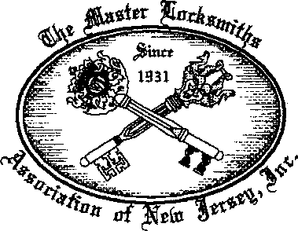

MLANJ 2002  
Annual Convention

April 18th thru April 21st Somerset, New Jersey

For More Information:

PO Box 2441

Morristown, NJ 07962-2441 Phone 973-627-6385 Fax 973-627-3246

Or visit our web site at **[www.MLANJ.orq](http://www.MLANJ.orq)**

Keynotes • March 2002

**APRIL ■ APRIL ■ APRIL ■ MARCH ■ MARCH ■ MARCH**

**upcoming**

3 3-4 5-7 ' 8

Southern Lock & Supply Co. ALOA Board Meeting ISC EXPO/West at the Las Vegas PRP • Dallas, TX

Trade Show and Learning Expo Las Vegas, NV Convention Center Ashley Manson

Coliseum, St. Petersburg, Fla. For more information: (800) 532-ALOA (2562)

Call 800/282-283 <http://www.iscwest.com> [education@aloa.org](mailto:education@aloa.org)

|  |  |  |  |
| --- | --- | --- | --- |
| 9 | 9-10 | 15 | 18-23 |
| Florida West Coast | Ozark Professional Locksmith Assn. | Central & Southern Colorado | ACE Classes • Basic Locksmithing |
| Locksmith Association | Annual Retreat w/Steve Young | Locksmith Assn • St. Joseph Church | Appleton, Wl • Fox Valley Technical |
| Installation Banquet | Inn of the Ozarks, | 1830 S. Corona Ave., | Jerry Antoon • 920-735-2406 |
| Sam Seltzers •Tampa, FL. | Eureka Springs, AR | Colorado Springs | 920-735-2414 • antoon@foxval- |
| Contact: James Barnhardt | Contact: Betty Gray | Contact: Barry Meyer, CRL | leytech.com • [www.fvtc.edu/Security-](http://www.fvtc.edu/Security-) |
| 800-486-7998 | (501)524-3660 | (303) 688-4104 | CrimePrevention/Locksmithing%20lndex  .htm |

|  |  |  |  |  |
| --- | --- | --- | --- | --- |
| 19 | 21-23 | 21-24 | 22-24 | 23-24 |
| Mount Diablo Chapter of CLA | California Locksmith Assoc. | Clark Security Products | California Locksmiths Assoc. | Lou-Miss Spring |
| Meeting 7pm | Trade Show and Educational | Tradeshow | Education and Trade Show | Education Conference |
| California Maritime Academy | Conference | Holiday Inn O'Hare | Anaheim, CA | President Broadwater Casino |
| Vallejo, CA | Disneyland Hotel | Chicago, IL | Contact: Suzanne Harmony | Bilox, MS |
| Contact: Art Patch, CCL, CML | Anaheim, CA | [www.clarksecurity.com](http://www.clarksecurity.com) | (800) 767-5625 | Contact: Glen Sawyer |
| (707) 642-2661 | Contact: Dennis France |  |  | (318) 336-5288 |
|  | (909) 485-6903 |  |  | [gbsawyer@telepak.net](mailto:gbsawyer@telepak.net) |

Minnesota Chapter of ALOA

Membership Meeting  
Broadway Pizza  
2025 West River Road  
Minneapolis, MN

|  |  |  |  |  |
| --- | --- | --- | --- | --- |
|  |  |  |  |  |
| 8-1 3 |  | 9 |  | 13-14 |
| PRP* SAFETECH 2002 • Reno NV |  | Fox Valley Chapter of ALOA |  | Folson, MT |
| Contact ALOA • (800)532-2562 or |  | Membership Meeting |  | 2 ACE Classes |
| (214)827-SAFE (7233) |  | Columbus Club |  | Contact: Todd Rasmussen, CRL |
| [www.savta.org](http://www.savta.org) |  | 2531 N. Richmond St. |  | (406) 883-2950 |
| [convention@savta.org](mailto:convention@savta.org) |  | Appleton, Wl |  |  |
|  |  | Contact: Norm Zurawski, |  |  |
|  |  | CRL [lockeyone@lockeyone.com](mailto:lockeyone@lockeyone.com) |  |  |

|  |  |
| --- | --- |
| 16 |  |
| Mount Diablo Chapter of CLA Mee | -ting |
| 7pm • California Maritime Acade | my |
| Vallejo, CA |  |
| Contact: Art Patch, CCL, CML |  |
| (707) 642-2661 |  |

17-21

Master Locksmiths Association of New Jersey • Annual Convention April 17-21 • Garden State Conventior Center and DoubleTree Hotel Somerset, NJ

Contact: Joseph LaVigne II, CRL 973/267-8884

18

Florida West Coast Locksmith Associa­tion (FWCLA) • General Meeting 8pm (Detex w/Accent Marketing)

Temple Crest Civic Center 512 Miller Ave. • Tampa FL Contact: Rob Curry (727) 849-1812

18-21

PRP»20 ACE Classes and PRP Somerset, NJ Dan McGlynn, CML 973-267-8884 973-538-1588 [dfmcml@home.com](mailto:dfmcml@home.com) [www.mlanj.com](http://www.mlanj.com)

19

Central & Southern Colorado Locksmith Assn • St. Joseph Church 1 830 S. Corona Ave., Colorado Springs Contact: Barry Meyer, CRL (303) 688-4104

20

Greater Houston Locksmiths' Assn. Automotive Class w/Jim Hetchler Texas Auto Auction, Houston Contact: Ed Stites (979) 323-9919

19-21

Minnesota Chapter of ALOA PRP Education weekend, Maplewood, Minnesota.

For more information: Michael Mattern, CRL (952) 544-3399

26-28

South Carolina Locksmith Assn. Meeting

Holiday Inn NE (1-20 & Two Notch Rd.) Columbia, SC Contact: Jean Griggs (803) 432-9008

5

s

1

Minnesota Chapter of ALOA Membership Meeting Broadway Pizza 2025 West River Road Minneapolis, MN

10

• Dallas, TX Ashley Manson 800) 532-ALOA (2562] [education@aloa.org](mailto:education@aloa.org)

16

Florida West Coast Locksmith Association (FWCLA)

General Meeting 8pm (Don-Jo w/Buddy Brown SBS Assoc.) Temple Crest Civic Center 512 Miller • Tampa FL Rob Curry (727) 849-1812

17

Central & Southern Colorado Locksmith Assn St. Joseph Church 1830 S. Corona Ave., Colorado Springs Contact: Barry Meyer, CRL

2

North Jersey Master Locksmiths Association 8th Annual Flea Market 9a-2p • Quality Inn Lyndhurst, NJ • Contact:

Nick Hart 201/944-7547 or Jeff Sitar at 973/777-0620



**OCTOBER I SEPTEMBER ■ AUGUST ■ JULY ■ JUNE ■ JUNE**

event

s

14

PRP • Dallas, TX • Ashley Manson (800) 532-ALOA (2562)

18

Mount Diablo Chapter of CLA Meeting 7pm • California Maritime Academy Vallejo, CA

Contact: Art Patch, CCL, CML (707) 642-2661

20

Florida West Coast Locksmith Associa­tion (FWCLA) • General Meeting 8pm Temple Crest Civic Center 512 Miller Ave. • Tampa FL Contact: Rob Curry (727) 849-1812



21

Central & Southern Colorado Locksmith Assn • St. Joseph Church 1830 S. Corona Ave.,

Colorado Springs Contact: Barry Meyer, CRL (303) 688-4104

22-23

Greater Houston Locksmiths' Assn.

Safe Penetration Party

w/Dave McOmie

Location TBA

Contact: Ed Stites

(979) 323-9919(303) 688-4104

21

Mount Diablo Chapter of CLA Meeting 7pm

California Maritime Academy Vallejo, CA

Contact: Art Patch, CCL, CML (707) 642-2661



13-14

DHI Convention and Expo, Chicago, Illinois.

For more information: [www.dhi.org](http://www.dhi.org)

18

Florida West Coast Locksmith Association (FWCLA)

General Meeting 8pm (Steel Craft Doors w/Steve Puleo l/R) Temple Crest Civic Center 512 Miller Ave. • Tampa FL Contact: Rob Curry (727) 849-1812

19

Central & Southern Colorado Locksmith Assn St. Joseph Church 1 830 S. Corona Ave., Colorado Springs Contact: Barry Meyer, CRL (303) 688-4104

22-28



ALOA 2002 Rosemont, IL Contact ALOA (800) 532-2562 [www.aloa.org](http://www.aloa.org) [convention@aloa.org](mailto:convention@aloa.org)

22-28

South Carolina Locksmith Assn. Meeting

Quality Inn (1000 Hearon Cir) Spartanburg, SC Contact: Jean Griggs (803) 432-9008

14-16

ISC EXPO/East, Orlando, Florida.

For more information: siaonline.org

16

Central & Southern Colorado Locksmith Assn • St. Joseph Church

1830 S. Corona Ave., Colorado Springs Contact: Barry Meyer, CRL (303) 688-4104



19

Florida West Coast Locksmith Associa­tion (FWCLA) • General Meeting 8pm Temple Crest Civic Center 512 Miller Ave. • Tampa FL Contact: Rob Curry (727) 849-1812

14-19

ACE Classes • Basic Locksmithing Appleton, Wl • Fox Valley Technical Jerry Antoon • 920-735-2406 920-735-2414 • [antoon@foxval- leytech.com](mailto:antoon@foxval-leytech.com) • [www.fvtc.edu/Security- CrimePrevention/Locksmithing%20lnde](http://www.fvtc.edu/Security-CrimePrevention/Locksmithing%20lnde) .htm

25-29

SERLAC Trade Show - Orlando, FL [www.serlac.com](http://www.serlac.com)

Contact: Steve Blizzard (800) 845-529

17

Florida West Coast Locksmith Associa­tion (FWCLA) • General Meeting 8pm Temple Crest Civic Center 512 Miller Ave. • Tampa FL Contact: Rob Curry (727) 849-1812

27-29

Jo-Van Distributors Inc.

2002 Annual Security Show and Educational Conference Contact: Joan Daniels or Larry Malo at 416/752-2238 or 888/752-7210

23-27

Greater Philadelphia Locksmiths Association • 2002 Convention, Radisson Hotel • Mt. Laurel, NJ Contact: Nelson Dayton 610/688-9188 or Ed Fitzgerald at 856/665-1311

Sept. 30-Oct. 5

Pacific Locksmith Association

Annual Convention

Denny's Restaurant Tualatin, Ore.

Contact: Karl Kretsch, CRL

541/741-6902

[www.pla-pro.org](http://www.pla-pro.org)

25-27

South Carolina Locksmith Assn. Meeting 20th Anniversary Banquet & Installation of Officers and Board Holiday Inn NE (1-20 & Two Notch Rd.) Columbia, SC

Contact: Jean Griggs (803) 432-9008

|  |  |
| --- | --- |
| Don’t Miss | SAFETECH 2002 |
| these ALOA | APRIL 8-13 |
| Events! | JOHN ASCUAGA'S NUGGET RESORT |
| RENO, NEVADA • 1-800-443-1482 |

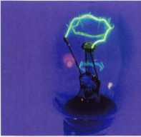

**core**

Toys For Tots in Minnesota

ALOA members from the Minnesota Chapter presented gifts this past holiday season to their local Toys For Tots Foundation. Pictured are two local marines representing Toys for Tots with Minnesota chapter officers Michael Mattern (left) and Brian Droen.

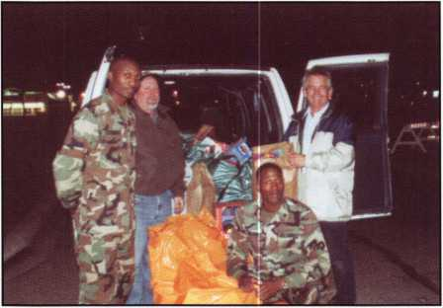

Need Help?

At ALOA, we want to make sure you are getting as much bang for your membership dues buck as we are able to give you. If you have had problems getting membership services, or have a question regarding member services, please contact Bill Gibson, exectuve director, at 800/532-2562, or e-mail: [charlie@aloa.org](mailto:charlie@aloa.org).

Let Us Know!

If you have an opinion to offer on ALOA, the state of the industry, or life in general, we want to know about it! Submissions to the "Mailbox" sec­tion of Keynotes are printed on a space-available basis. Write to:

"Letters to the Editor"; ALOA; 3003 Live Oak Street; Dallas, TX, 75240; FAX 214/827-1810; e-mail: [editor@aloa.org](mailto:editor@aloa.org) <<mailto:editor@aloa.org>>.

An Open Thanks from WTC Member

Seth Pehr, a New York city locksmith whose World Trade Center shop was demolished in the terrorist attacks of Sept. 1 1, recently asked ALOA to thank those who helped donate equipment to him so he could begin to pick up the pieces of his business left devastated by the terror­ists. Members from near and far donated a slew of equipment to help Seth get back on his feet, and he is eternally grateful to those who helped him.

TimeMaster Relocates to Kentucky

Separating the distributing arm (TimeMaster) from the manufacturing arm (TMI) of his businesses, Dan Graffeo, CRL, CMST, has formed a managing partnership for both companies with Tim Abner (formerly of Sargent & Greenleaf).

The first step taken was to Kentucky, where the formerly Kansas-based operation now is open for business at : 157 Venture Court, Suite 9, Lexington, KY 4051 1. You can reach the new office toll free at 888/798-8464, or visit them on the web at [www.time-master.com](http://www.time-master.com).

Certifications

CRLs

Don Martin Cut Bank, MT

Peter Mortel Missoula, MT

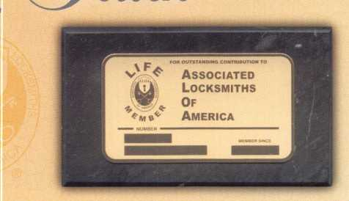

***Order*** onCine

***at*** [www.afoa.org](http://www.afoa.org)

or caff

(8’>00)532-‘AXO'A

*(get* your’s today for onfy $20!

Now you can show off your ALOA membership in style. Regular members and Life Members can simply glue the membership card onto the marble (as shown). Don't miss out on this affordable, official ALOA display. The classy slate-colored marble comes with felt padding for your desktop or van. It can be easily mounted to show off your ALOA pride in your office/shop! The cost for you to display your professional pride, you ask? Only $20!

J2|| Keynotes • March 2002

**ALU A** Locksmiths **SecureAmerica**

**ALOA Membership. Prove You're a Pro**

Pick **Up** Some **Players!**

Attention Current Members! As tbe best security pros in  
the world, you play a vital role in making ALOA what it  
is. You make our industry hym, and we're going to  
prove it this year by offering you more benefits than  
ever. For the entire calendar year of 2002, those who  
recruit new members will receive special gifts from  
ALOA. We're asking you to prove you're a pro by sup-  
porting the only professional organization that exists to  
help educate, protect and promote security profession-  
als in America and beyond. Here are some of the  
details of our campaign:

**For New Members!**

All newly recruited members receive a useful ALOA  
11-piece pick set from LAB, plus our stirring "ALOA  
Locksmiths Secure America" decal for the shop or van.

**For Current Members Who Recruit!**

1 new member: The useful ALOA 11-piece pick set  
from LAB.

5 new members: A handsome ALOA Polo Shirt (w/  
stitched logo)

10 new members: LAB's great Schlage/Kwikset  
Combination pin kit - plus membership in the ALOA  
President's Club, with your choice of a dazzling ALOA  
ring or a classic ALOA blazer (plus a periodic listing  
in Keynotes).

**For Chapters and Affiliates Who Recruit!**

If your chapter gets 15 new members: ALOA will send instructors out to your site for two free days of ACE classes FREE OF CHARGE! Plus, the chap­ter or affiliate that recruits the most new members gets three free convention packages for our blowout show in sparkling Las Vegas in July of 2003!

Don't pass up this fantas­tic chance for these grjfct free giveaways, an ™ expanded group of peers with whom to learn and grow, and the same fantastic education, protection and promotion ALOA has been providing for our great profession for almost 50 years! Call us today at 800/532-ALOA (2562) for more informa­tion, or visit us on the web at [www.aloa.org](http://www.aloa.org).

°oi Gift'*

C

rnmmmmmmm

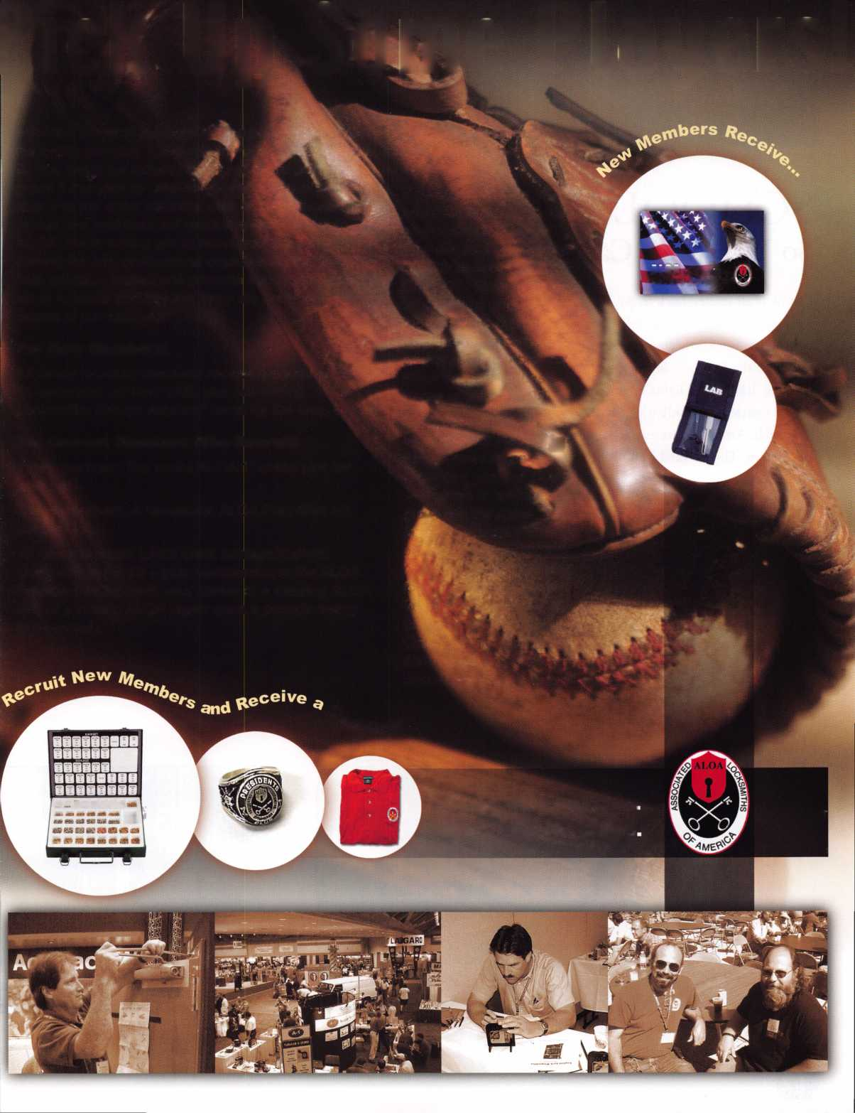

SCHOOL DAZE

So You Want Card Access • by Don Seburg

I think it all started back in 96’, when I realized that we needed something better than the key system that we were working with. We had a problem with access control in the school district. Back in the 70’s & 8o’s we had little or no key system. On weekends employee’s would come in to work on projects and sometimes bring their children with them. They would let the kids play in the gym area while they worked. And when they were done for the night, they would leave the building, leaving the lights on and in some cases even leaving the doors open. This was getting to be a real problem for the school district. Not only was it costly leaving gym lights on, but also the lack of security when the doors were left ajar was too much. After some research we found what we thought was the perfect answer. We went to a restricted and patented key system. This worked well for several years. The buildings realizing the importants of access control kept a close watch on the keys . They would check them out on Friday and collect them back on Monday. Because the employee could not copy the key, we felt pretty confident that we had a handle on the problem.

After some success, we had another setback. One of our administrative employees’s decided that all of our employee’s should have access to the buildings 24/7. At this point we found our selves in a real pickle. Not only do we have keys float­ing all over the place, but now it cost ten times as much to get new ones cut because of a price increase. The most costly part was when an employee would loose a key, that not only opened the front door, and the side door by the parking lot, but also the entrance to the athletic field. At this point we would have to scramble to get the doors repined and get keys cut. Then we had to pass out new keys to fifty to one hundred other employees. As you can imagine, after a few years of this. We started to hold the change keys for a few years (approximately 6 to 8 years) and then we would recycle them to hold down the costs. At a cost of just under six dollars a key we averaged five hundred dollars for the secondary schools and about half that for the elementarys.

2

Keynotes • March 2002

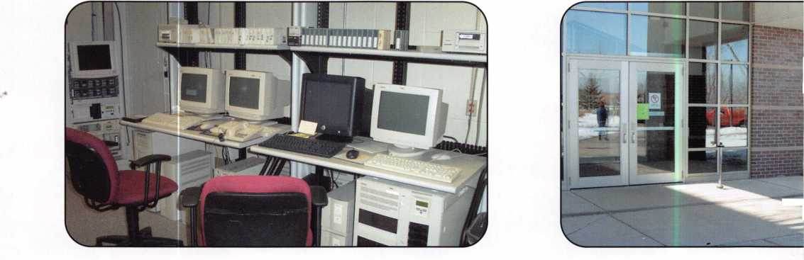

So it’s not hard to understand why we were looking so hard  
for another way One of the other problems we encountered  
was the lack of information thrown our way because we were  
considered to be the end user. When the lock shops would  
get fliers and invitations to trade shows we would not.  
Therefore it was much harder to find a solution.

Another problem we encountered with the high cost of  
replacing lost keys, was that no one would report there key  
lost. They would try to hind the loss, and make every excuse  
in the book to get another key. Once we had an employee tell  
us that his key fell overboard and went to the bottom of the  
lake. Two weeks later it resurfaced in the parking lot where  
he taught. Imagine our surprise!

Well enough of why we went looking for something new.  
Eventually I heard about keyless entry systems. Because of  
the high costs of hard wire systems I started looking at stand-  
alone systems and thought I had a good one to start with.  
That is, till the company rep. was walking out the front door,  
and suddenly wheeled around, looked at the aluminum frame

on the door and asked is this one of the doors to get my prod-

uct? He looked at me, and said my hardware will not fit frames smaller then five and a quarter inchs wide. Back to the  
drawing board. After a few more tries at it, we got the administration to allocate enough money so we could look at a  
hard wire system.. That’s when the real fun began.

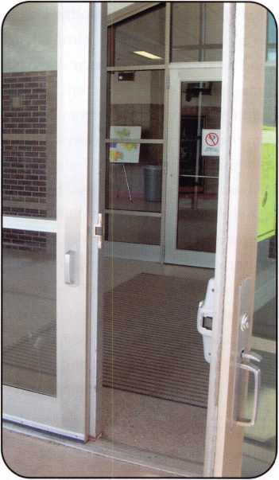

When we started out with this project we wanted to ask our school administrators for their input. Things like which  
three entry’s would best suit their school. Three entries for the elementarys and five entries’ for the secondarys. We also  
saw fit to make the receiving rooms mandatory. This left just two entry’s to choose from, for the Para’s and employee’s  
and night activitys like Community Ed programs that take place after school. With thirty school buildings in the mix this  
got to be quite a project all by it self. After talking to the administor’s and coming to some agreement on the entry’s, we  
went to some of our hardware Rep’s to get some incite on electrified locks and panics and strikes. In the beginning we  
thought it would be simpler to just go with electric strikes. But as we asked around the Rep’s convinced us that going with  
the more expensive retractable latch panics we would have less trouble and better security This wound increase our costs  
because of the more expensive power supply’s to get the latch to retract. This more expensive power supply

is necessary to spike the latch to retract. Because of all the different types of doors and frames and hard-  
ware we have, we found it very difficult keep this all straight. And that no one setup would work for every-  
thing. We had to go to every building and assess each and every entry according to its usage

We then asked our architectural firm to draw up a bid for a good system. We were also able to get CCTV  
added. They laied out a system they thought we could make good use of. We then went on a short field trip  
to see a similar card access and CCTV system in action that they had put in place several years earlier. This  
system was older and they were using a tape storage system for their CCTV memory. We were told that  
our system would have a digital storage system that would make it easier to work with. So we put the sys-  
tem out for bids. After two tries we finally had a bid we could live with.

After we started installing the panics we were surprised to find that we could no longer dog open our panic  
bars. The retractable latch device replaces the dogging feature, and therefore the door with the card reader



Keynotes • March 2002

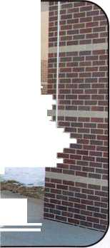

could only be dogged electronically This presented  
another problem. If we electronically dogged the doors  
open and we had a snow day, that does sometimes happen  
in Minnesota, our doors would open with know -one in  
the building. This of coarse is not acceptable. The other  
problem that presented itself, was when Community Ed  
had something going on in the building in the evening,  
and we have electronically dogged the doors open, if the  
event ended early someone would have to stay there till  
the computer relocked the doors. Because of this, we went  
back to the electric strikes. This would allow us to dog the  
doors open as before. It was then we also discovered we  
have several mullions that will not accept the electric  
strike, because of the narrow body of the mullion. We had  
to stay with the electric panics and install key operated  
switches to hold open our doors manually.

And to make things even more confusing, I found another  
way to dog open the panics, thanks to my local hardware  
Rep. and of coarse this was even more expensive because  
of the additional hardware so we choose to pass on this  
suggestion. Needless to say even though we thought we  
had done a very thorough job of looking at our hardware  
we were wrong.

We also found that the electrified locks that were selected for the receiving doors could not be manually opened during school hours for deliveries at the loading dock. So we found ourselves going back to electric strikes where we could.

After we thought we had most of our hardware problems under control, we dove head long into the software. Our archi­tects had put together a very nice system with a computer at every school. And one central computer at the administra­tive offices. The company that won the bid had exactly the same type of program. The bid company asked how we want­ed to put together a database. We told them that we had a program from our state payroll database. So we down loaded 3500 employees to a disc and let them put it in the program. Later we found out that there was more than one entry for some employee’s because some of them had more than one position. And some worked in more than one building. We are still trying to correct that oversight. We also found out quite by mistake that if our main computer cannot talk to the client computers we cannot change cardholders or time zones. This is another reason not to open doors by the computer only. If the system goes down you are stuck with it until such time as your system comes back up. Although the doors will operate even if the system goes down, they will only follow there last command from the main computer.

I also found that you do not want to make your time zones and access groups to complicated to begin with. They will become complicated all by them self. The first timezone I set up, I tried to go with the same as a keyholder, which was 24/7. The next group I set up was the non-keyholder. This group only has access during open hours at the site. Then of course we have our maintenance crews and repair employees that need access. We also have our administrators that need 24/7 access. As you can see it does not take long for many groups to evolve and for it to get very confusing.

After all is said and done I must say that this has been a learning experience. Even though I felt that I had a good working knowledge of our key system. I was surprised at how much one can learn. At the risk of possibly repeating myself I have to urge anybody that is going to embark on this project to look very carefully at every aspect of the project. And talk to the people that are involved and try to understand what they do and how they do it. Q

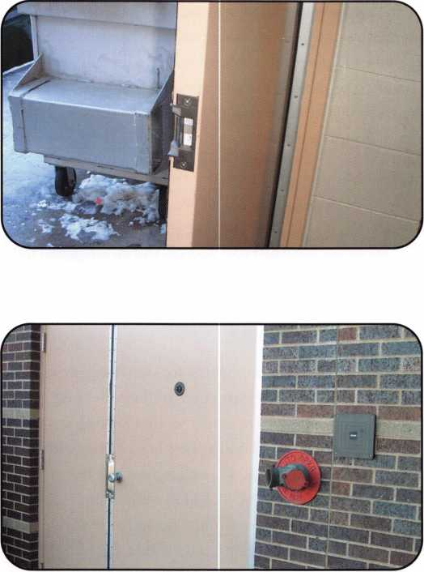

Keynotes • March 2002

TOOLS LIMITED

**[www.intralocktools.com](http://www.intralocktools.com)**

neui

affordable

Super strong rare earth magnets

at gripper with reversible shaped

ws to grip most dials

Easy to assemble mounting jig  
Self contained - no computer required

Phone: (888) 264-6627 A I 2639-B Progressive Ulay

(604) 852-8904 **|| I I TALvIUV** Abbotsford, B.C.

USB: (562) 699-0060 **TOOLS LIMITED U**2**T**6**H**8

Serving industry with superior products since 1985.

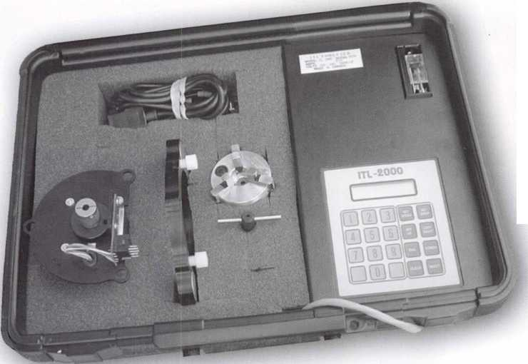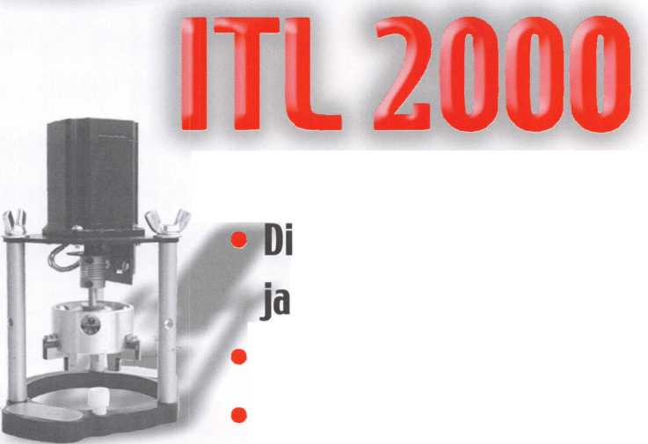

Assessing AC Controllers: Neffy’s Dirty Dozen

By Bill Neff, CML

I guess I am now showing my age, but access control has been around for years. In fact, even in the January 1981 issue of Keynotes you can find and article written by the late, great Robert C. Holcomb from Buffalo, NY, (who, by the way, was an ALOA Instructor and Past-North-East Vice President of ALOA). In that article, he stated that locksmiths should consider this new market, because it was going to be the wave of future. Bob was definitely a man ahead of his time and even back then, he had a vision that our industry was on the road to vast changes.

The truth is that in 1980, access control products were only estimated to do $19 million in annual manufacturer sales. Today, it is over $1.7 billion dollars in annual manufacturer sales. I miss Bob and it was a pleasure to meet a guy like him, who had the desire and the ability to inspire others to reach forward to explore new avenues that helped us, not only to stay in business that day, but helped us well into the decades ahead. He was truly one of my mentors and I am eternally grateful for knowing him.

Well, times have truly changed since those days. The year is now 2002 and we have bigger and better technology. But we also have what is called “information overload,” since technology is changing about every 18 months or so. Many of us in the Access Control market find it a challenge to keep up, but the rewards are well worth the invest­ment of time and money. I would like to pass on a few insights that I have encountered in all of my years of doing access control. In this article, I will only touch on the highlights of what you should strive for in doing access control. After teaching many access control classes, I have found out that many locksmiths do not understand the core concepts of basic electrical circuits such as relays, switches, power supplies and electrical laws, just to name a few. My suggestion is to take it one step at a time and learn the fundamentals of electricity — and learn it well! There are many courses taught on this subject both in associations, local schools, colleges and correspondence courses. What I find is that most locksmiths are hands-on guys and gals. We like to rip in and tear apart and fig­ure things out, sometimes the hard way. This method does work sometimes. In fact, especially when you learn from your mistakes, you do get a fantastic education, but it does usually come also at a fantastic price. I suggest that you enroll in some courses and learn electricity.

If you wish to do multiple door installations, my suggestion is become PC-literate with different operating systems and computer hardware. Now you need to know the primary parts that make up an access control system today. One thing to mention in the access control industry is that you will not find a standardization of “Glossary of Terms.” It’s a language in itself and by just jumping in and asking questions, in a short time, you will pick up the lingo. You might ask, why is it not standard? The simple reason is marketing and confusion seems to go hand in hand in the technology world. For instance, the main part of AC unit, which in a sense is the brains of the system, is most often called a controller. It can also be called a Main Logic Board, Main Controller, Logic Board, Door Control Device, Door Control Unit, Door Interface Unit, Motherboard, Master Circuit Board to name a few. See my point? For all intents and purposes, let’s call it a controller. But remember, it’s the brains of your system, so don’t choose one lightly

There are many things you can research if you want to get into assessing a particular AC controller. From my perspective, here are the 12 things you really should go after early and often when thinking about AC controllers. So here’s the dirty dozen:

Keynotes • March 2002

1. AC controllers have ports that can accept input and output devices. In general, an input device has an input port that can connect to a reader, computer, or alarm contact (to name a few). The output is merely the relays which can control the electric strikes, electric locksets, electric deadbolts, electro-magnetic locks, electrified exit devices, light systems, air handling systems, alarm systems, CCTV (again, to name a few). This is what I look for in a controller. I myself like to purchase single door controllers since most access control systems start small and are increased as the customer demands more doors to be controlled by electronic access. The advan­tage of single door controllers is that you only have to purchase what you need, and that’s always less expensive than paying for a multiple door controller.
2. A single door controller can save you in labor, wire and sundries costs since you kept your wire runs short by installing the controller in near proximity to the door opening, eliminating the need for long wire runs that are essential when using a multiple door controller.
3. I select a controller that can use different PC operating systems like, DOS, Windows 3.1, Windows 95, Windows 2000, Windows NT (to mention a few; are you getting the hang of the universality of this yet?) You might say, why DOS? I will tell you why: Many security depart­ments get the hand-me-down computers in their com­pany and what it boils down to is that they only want to control who goes where and when. And they want

to be able to print a hard copy of what events occurred. Think about it. Access control is a little like a microwave oven: It has a lot of bells and whistles but the reality is, you just want to heat things up, not do four stage cooking! The point is to have a controller that has a flexible system, so you can upgrade without taking out but rather, only by adding to. Of course, you always charge for additional enhancements like software upgrades.

1. I look for flexible communication formats that the con­troller can handle like IR (Infrared Transfer), RF (Radio Frequency), TTL (Transistor to Transistor Logic), RS232, RS422, RS485, and TC/IP. I will explain these various communications formats in a latter article.
2. I look for a controller that has these hardware features on their controllers. This is a fact: Controller boards do fail, especially when they get hit by a direct bolt of lightning. I like a controller logic board that can easily be removed and the wire connections unplugged with­out the need to reinstall all the wires into the wire con­

nectors onto the new replacement board and that firmware can be easily removed or hot flashed when the manufacturer makes improvements to their hardware.

1. At the very least, I look for a controller to be able to accept a 26 bit Wiegand format for input devices like readers.
2. Look for a controller that has at least two relays one for the strike and one secondary relay to be used for various applications like shunting door alarms, triggering CCTV systems, activating an audible alarm like “Door Ajar” or a mirror action caused by another system that is integrated by use of dry contacts and a minimum of two alarm inputs used to monitor door sensing etc.
3. The controller must be able to function without the dependency of a PC.
4. The controller should have a buffer and be able to store at least 2000 events like valid entry, invalid entry, etc., and the data should be set up in what is called a FIFO, which means first in, first out. Another note, the data for invalid attempts should be limited in storage capaci­ty, because an unethical user could fill up the storage buffer with invalid data and by this process, delete the audit of a valid entry.
5. The controller should be able to control at least 2000 card holders. My recommendation is 10,000.
6. The controller needs to be priced low enough for you to compete in today’s open AC sales market.
7. The manufacturer of the controller should have a track record in the market place. Remember: There are sever­al hundred access control manufacturers making access control products and like the alarm industry of the 1980s, over half will not be in business in the next five years. Be cautious and ask to see the company profile. Make sure they are solid. After all, it is your company’s image that will get hurt if they go out of business.

In future articles, I wish to go into detail on communica­tion formats, software applications and database require­ments, what really is “open architecture,” card reader and bio-metric devices, card technologies including smart cards, what you should demand from an access control vendor, various locking devices, evaluation of systems environ­ments, special applications and integration.

If you wish to know more about access control, you can participate in my comprehensive access control class that I will be teaching at the MLA of NJ in April and at the ALOA Convention in Chicago. Best of luck... Q



Keynotes • March 2002

.29.95

.19.95

.19.95

.29.95

.29.95

29.95

.79.00

.45.00

.85.00

.19.95

.29.95

.19.95

.29.99

.19.95

.55.00

.39.95

.89.95

.39.95

...25.00

...27.00

...19.95

...39.95

...14.95

...34.95

...45.00

...29.95

.175.00

.175.00

9.95

...99.00 .155.00 .1 10.00 ...59.95 .1 10.00 .1 10.00 ...95.00 .95.00 ...39.95 ...29.95 ...29.95 ...29.95 ...29,95 ...29.95 .29.95 ...29.95 ...29.95 ...29.95 ...29.95 ...29.95 ...29.95 ...99.00 ...99.00 ...29.95 .115.00 ...69.95 ...14.95 ...27,00 ...25.00

...25.00

.529.00

of Our Titles...

Learn About Basic Electricity

Spacing and Depths, vol 1

Spacing and Depths, vol 2

Filing for Dollars

Antique Padlocks

VATS Made Simple (Revised)

Guide to Transponders

2000 Transponder Update

Bread & Butter

Locks and Lockmakers of America

Learn About Electronic Locking Devices

The Best of Locksmithing, vol 1

Logical Lock Diagnostics

How to Pick Lever Locks

Fundamentals of Master Keying

Guide to Electronic Locksmithing

Security Solutions Locksmith Marketing Program  
The Ultimate Techtips Collection

from Apprentice

Reading

Door Lock Encyclopedia

Lock Repair Manual

Interchangeable Core Cylinders

Picking & Impressioning

The Lure of the Lock

High Security Safes, vol 1

High Security Safes, vol 2

Safeman's Guide, vol 1 3

Safe Deposit Depth and Space Manual

Safe Technician's Reference Manual

Gun Safes

Modern Safe Opening

Dave McOmie on Vault Doors, vol 1, Bank Vaults

Dave McOmie on Vault Doors, vol 2, Fire and Plate Vaults ..

Modern Safe Locks

Drilling Safes

Safe Deposit Box Service

Foreign Car Impressioning Book

Impressioning Ford and GM Side Bar Locks

Automotive Lock Servicing Update #1: GM 10-Cut Locks

Automotive Lock Servicing Update #2: GM 10-Cut Locks

Automotive Lock Servicing Update #3: GM 8-Cut Locks

GM Locks: Perfect for the Beginning Locksmith!

Ford Locks: Pin Tumbler and Ten-Cut Systems

Chrysler Pin Tumbler Locks

Chrysler Double-Bitted Locks

Toyota Split-Tumbler Locks

Basic Door Panel Servicing

Advanced Door Panel Servicing

Motorcycles on CD

The Guide to Motorcycles

Japanese High Security Auto Servicing

Revised GM Steering Column Course

Foreign & Domestic Auto Service

Auto Lock Service

The Sieveking Auto Key Guide & Illustrated Cross Reference

Servicing Interchangeable Cores—Sargent

Servicing interchangeable Cores—Arrow, Best,

Eagle, Falcon, and Lockwood

The Ultimate CCTV Program on CD Rom

Just

a Few

**Visit our Website or call to place your order today!  
[www.aloa.org](http://www.aloa.org) • (214) 827-1701**

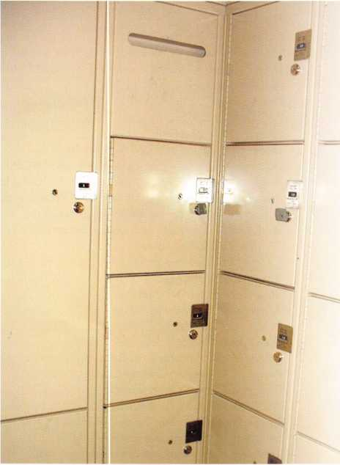

How many quarters

have you stuck into the slot in the side of the locker door at the

gym or pool? Ever wonder

what makes it tick? I know

I’ve wondered, but until recently

I could only wonder how they work.

Our police department uses a bank of “Sentinel” coin lockers for overnight and weekend storage of evidence, until the evidence clerk can log the materials into the storage area. Fortunately for the offi­cers, the lockers have a free mode. The reason I was called on this type of job recently is that a couple of the lockers

Keynotes • March 2002



Inside Tiffin’s “Sentinel” Coin Lockers

Greg Perry, CML, CPS

were inadvertently put into the pay mode and a key was lost for one locker.  
Tiffin Metal Products company of Tiffin Ohio produced these lockers.

They manufacture “Sentinel” lockers for a variety of applications. There is  
little difference between coin required and non-coin required locks.

The evidence clerk had the instruction manual and several copies of two  
different keys tagged “Controlled Key # 2” and “Controlled key #3.”

The cylinders and keys are manufactured by Illinois Lock. The Number 2  
key is the master key for opening the lockers if a key is lost or misplaced.  
The Number 3 is the key I needed to set the position of the cam. There  
are four positions available. The first is vertical or pay mode. It is this  
mode that requires the use of the appropriate number from one to four  
quarters to allow the bolt to be thrown or extended and the operating key  
removed. The second is for cylinder installation and removal, about 5 and n  
o’clock. The third position, about 4 and 10 o’clock, is the “free mode” or  
no coins required. This is the position all the doors should be set to for  
this application. The fourth position is the removal position, 180 degrees  
from the pay mode; it is used for both installation and removal of the  
mechanism. By now, some of you may be wondering what happened to  
“Controlled Key # 1.” The Number 1 key is used to access the coin collec-  
tion bins. Since this application is for evidence collection, the collection  
bins were not installed. No need for a “Controlled Key # 1” on this job.

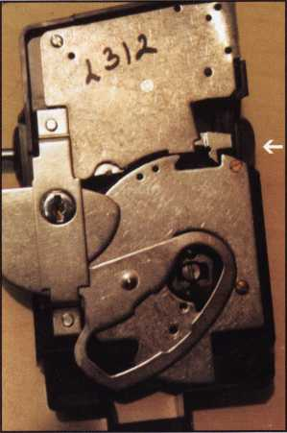

photo 2—CYLINDER REMOVED  
Lock is in normal pay mode.

Keynotes • March 2002



photo 3—CYLINDER INSTALL POSITION  
The cam is cut wider  
to allow for cylinder installation.

photo 4—FREE MODE The locking dog is lifted.

photo 5—REMOVAL POSITION

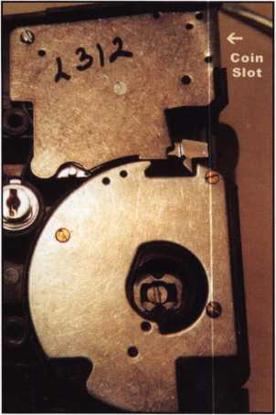

photo 6—COUNTOUR CAM REMOVED

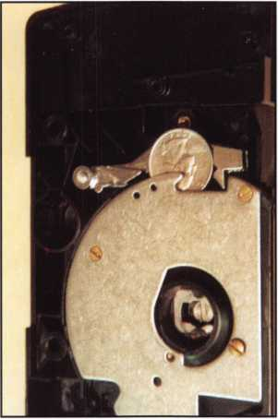

photo 7—A QUARTER IS DROPPED  
INTO THE OPERATING CAM

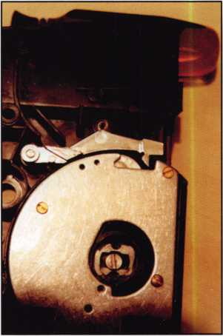

photo 8—QUARTER IN PLACE The quarter will lift the locking dog, allowing the operating cam to turn.

Let’s take a look inside the mechanism. Photo 2 is of the mechanism in the normal pay mode. The operating cylinder has been removed. The control cam flag portion to the left of the control cylinder locks the unit into the door. The locking dog indicated by the arrow will prevent the operating cam from turning to the door locked position. Photo 3 shows the mechanism in the cylinder install/removal position. Photo 4 shows the “Free” mode position. Although slightly concealed by the control cam, you can see the locking dog is lifted out of the operating cam. The last mode of the control cam is shown in photo 5, lock removal/install mode. The control cylinder can only get to this position with the operating cylinder removed. Photos 6, 7 and 8 have the control cam removed for clarity. Photo 9 is the operating cam turned to the locked position. If the unit collected quarters, they would drop into the frame, then fall to the bottom into the coin collection box. The number of coins required is selected by the position of pins installed in the numbered holes seen in photo 10

22

Keynotes • March 2002

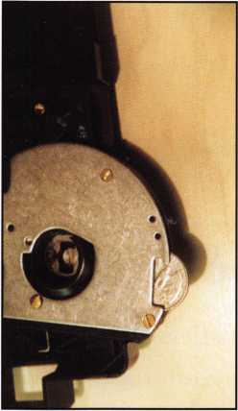

photo 9—CAM HAS TURNED The cam will drop the quarter into the coin box and down the frame.

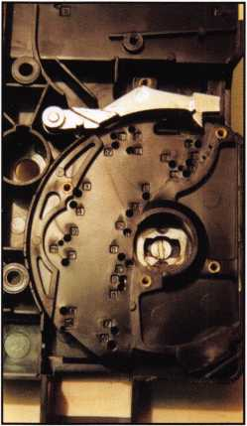

photo 10—COIN PATH  
The holes in the coin path are  
used to create different coin  
requirements.

(where the cam cover is removed). The pins trap the quarters in the appropriate posi­tion, and when the correct number of quarters are inserted, the last one will sit as seen in photo 8 and allow the cam to turn. If smaller coins are inserted, they will fall through the cam and out the bottom.

Ordering cylinders and keys required a letter from the end user to confirm that they wanted me to purchase on their behalf. Once that was in place, I ordered a couple of cylinders with a key each to replace the one missing a key, plus one spare. Once they came in, I wrote a nice invoice for another on-the-job training session! Q

*m*

c’1 DynaLock

Now there’s a delayed egress magnetic lock that forgives life’s imperfections. The DynaLock 3101B compensates for door misalignment with a simple, thumbwheel adjustment. What’s more, it protects against improper wiring and even the electronics are field-programmable and upgradeable.

The 3101B Delayed Egress magnetic lock makes installation easy... no external wiring is necessary except power. And the combination mechanical/ opto-electrical sensor is nearly foolproof. A 1500 lb. holding force offers high security. Also meets all relevant life safety and security codes, including NFPA101.

DynaLock

Electromagnetic Locking Systems

For high security in an imperfect world,

Call today:

877-DYNALOCK

(877-396-2562) or visit: dynalock.com

DynaLock Corporation

705 Emmett Street P.O. Box 2728 Bristol, CT 06011-2728 FAX 860/585-0338 [info@dynalock.com](mailto:info@dynalock.com)

Keynotes • March 2002

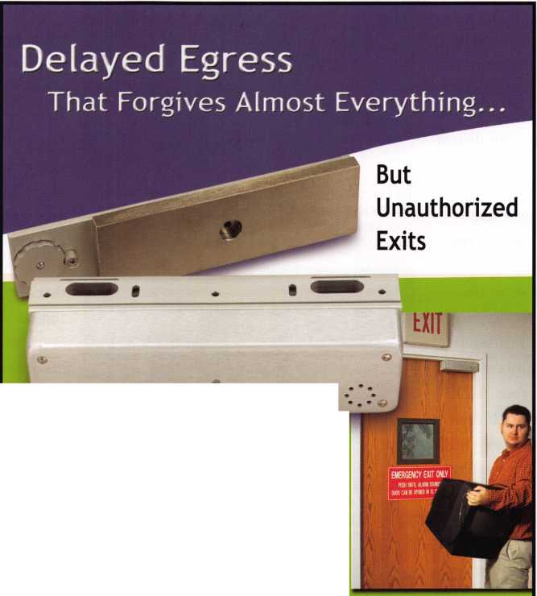

A big rock rolled in front of the cave entrance—that was state of the art access control for our distant ancestors. Add a fero­cious dog to the mix, and you were the absolute envy of the neighborhood. If you think about it, the basics really haven’t changed. Instead of a boulder protecting the cave entrance, we’ve got vaults with mas­sive steel doors. And the snarling dog? Just look under “Security” in your local Yellow Pages. Our canine friends are still a mainstay of the assets protection industry.

Has there ever been a true revolution in assets protection and access control? No.

It’s always been an evolution, with the innovators retaining and refining the prac­tical ideas of the past

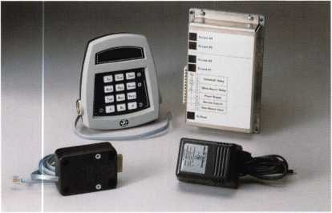

The basic components of a 6150 include the LCD keypad, the control unit, one or more lock bodies, and a plug-in power supply. The 6150 is not battery powered, although 9-volt batteries and a special cable can be used to operate it in the event of a power failure.

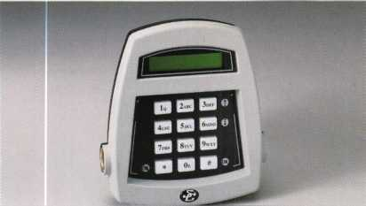

******

The keypad features two connection ports, tamper circuitry, and an LCD that displays information and prompts to let you know what the lock is doing and what it needs from you during operation and programming.

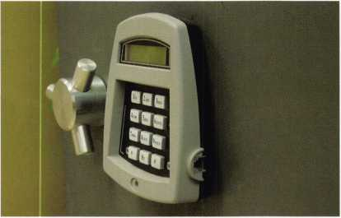

The left side of the keypad reveals a Dallas Touch Key Port. Programming and audit trail information can easily be passed through this port.

the S&G 6150

by Brian Costley, CML, CMST

while applying emerging technologies to further control the details of security in the most effi­cient manner possible. Whenever you see the term “revolutionary,” you’re looking at some­thing created by a marketing guy or an ad agency (a more expensive gaggle of marketing guys). As physical security professionals, we constantly see the same tried and true concepts presented within the framework of new tech­nology. When the result is an improvement, that’s evolution. A true revolution would be something like deciding as a society to give every criminal and potential criminal everything his or her heart desires to prevent theft. Hey, I didn’t say it was a good idea, but it’s definitely revolutionary.

A time honored method for protecting valu­ables has been to guard them. The technology could be a well disciplined soldier with a spear, a nasty tempered dog, a fortified structure (strong room) with a massive lock on a heavy door, or a specially built container that could only be opened by someone who knew its secret opening method. In modern terms, it could be an armed bank guard and his dog standing outside a vault with the cash locked in smaller safes inside. In many countries, this is exactly what you would see in a bank. The only concession to truly modern technology might be an alarm system.

During the business day, there are undoubtedly controls on who is allowed to enter the vault at prescribed times. Perhaps the teller accessing a

Keynotes • March 2002

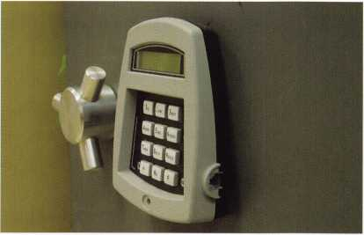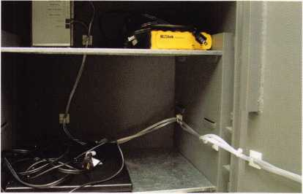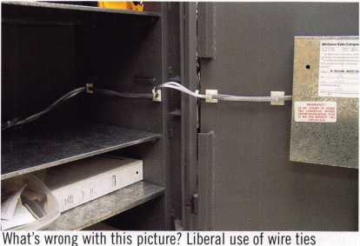

The right side of the keypad contains a port that accepts a serial cable connected directly to your computer. This eliminates the need for Dallas Touch Memory keys for programming and audit trail down­loads. The port is also used to connect an emergency batter cable in the event of a power failure.

cash safe must be accompanied by a supervisor when enter-  
ing the vault. So there are not only physical barriers to  
theft by outsiders, but also procedures to curb the threat of

theft by people

who normally  
have access to the  
vault and its safes  
during regular  
business hours.

Then there are  
the special proce-  
dures invoked for  
armored car pick-  
ups and delivers.

Due to the  
amount of cash  
and its exposure, a  
whole different set  
of security meas-  
ures is required.

All of this falls  
under the heading  
of access control,  
and you can see  
where the com-  
plexity of these  
different demands  
can add up to a lot  
of overhead quite  
rapidly.

Most of us don’t  
deal with bank-  
type security  
beyond servicing  
vault doors, time  
locks, and safe  
deposit nests.

However, you very  
likely have cus-  
tomers who share  
many of a bank’s  
security needs on a  
smaller scale. Most

of these needs focus on the  
customer’s safe.

and blocks is good, but the cable is unprotected. This is especially dangerous where the cable crosses the hinge side of the door.

Same safe, same problem. This cable is just waiting for someone to shove items into the safe and cut or crimp it. This was a retrofit installation, so don’t blame the safe manufacturer.

A good example can be found as close as your nearest fast  
food establishment. It’s a cash business with a fair exposure  
to armed robbery and burglary. It also relies on multiple

managers who each need access to the safe. Add  
into the mix the fact that fast food is a highly com-  
petitive business with margins that don’t allow lav-  
ish expenditures for bank-type security measures.

It wasn’t that long ago that the typical fast food  
establishment simply made do with a sturdy safe  
that was secured by a mechanical combination lock.  
It probably had a key locked inner drop compart-

ment where excess cash was stored until someone  
could make time to take it to the bank. If the  
owner was concerned about armed robbery, the safe  
might have a time delay combination lock. If you’ve  
been in the safe servicing business for any time at  
all, you’re familiar with the most prevalent  
headache involving mechanical lock combination  
change. Upon changing and checking the combina-  
tion, you would present the new combo numbers to  
the manager on duty. Some time later (most likely  
midnight Saturday), another manager would call  
your emergency service number to complain that  
the safe was no longer working. Invariably, the  
problem turned out to be that no one had bothered  
to give this manager the new safe combination.

The point of the story is that everyone who needed  
to access the safe had to use the same combination.  
This would typically be half a dozen people.

If there’s a shortage of funds in the safe, how is it  
possible to identify the responsible party? There  
may be an alarm and a safe to keep out the riffraff,  
but there is little in the way of protection against  
inside theft, sometimes referred to as “shrinkage.”  
The old system left a lot of opportunity for unex-  
plained shortages.

The injection of electronic technology has given  
the security level of safes an evolutionary kick in  
the pants. All the features needed to control safe  
access are now available in a reasonably priced  
package that many end users actually find easier to  
use than the older mechanical locks.

I have a great fondness for mechanical locks, and a fair understanding of their intricacies. Even so, I feel fortunate to have witnessed firsthand the birth and adolescence of

Keynotes • March 2002

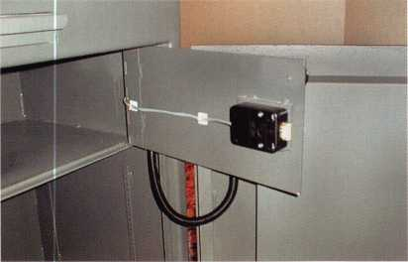

This is another safe with an interior compartment. Note the heavy plastic sleeve over the cable that cross the hinge side of the outer door (it’s hanging below the bottom of the inner door). However, there’s no protection inside the inner compartment. The use of wire ties and tie blocks is good.

Eile Configuration Window Help

electronic safe locks. The path has been quite rocky at  
times, but there is no stopping the infusion of this technol-  
ogy into the safe industry The consumer will have it no

other way From our  
side of the fence, we  
tend to see the diffi-  
culties of learning a  
new technology that  
changes every month.

The consumer is  
entirely focused on  
the proliferation of  
features and the con-  
venience of operation.

As you might expect,

I am most familiar  
with Sargent &

Greenleaf’s line of  
electronic locks, the  
Comptronic® family.

I have two or three  
favorites among these  
digital marvels. One of  
those is the 6150, a  
lock that provides a  
dazzling array of secu-  
rity features, and is  
easy to program (you  
knew the dirty “p”  
word was bound to  
show up sooner  
or later).

Two things make the  
6150 easy to program  
and re-program. One  
is its two-line LCD on  
the keypad. The dis-  
play makes it possible  
for the lock to help  
you with prompts for  
input. The other fea-

ture is a Windows-based software package that lets you  
control every aspect of the 6150. All brand bias aside, this  
is the most user-friendly lock software IVe ever seen. The  
graphical interface looks like it was created by somebody  
who actually uses safe locks.

LOCK TYPE r SINGLE CONTROL r DUALCONTROL <!■ MANAGER/EMPLOYEE

F Employee Authored

Feature Enable

r Long Close up to fi 3 D°y* F Short Close F Tamper r Duress

One of the many PC software screens. This one lets you control a number of features, including mode of operation, ability to use long closes, short closes, tamper, and duress features. You can also enable the remote control feature that provides extra lock control via an outside signal.

Lets back up just a bit before we jump into software  
specifics. The 6150 was designed to control two separate  
locks from a single keypad. The components consist of the

keypad, a control box, and the lock body (or  
bodies if you’re using two). The optional soft-  
ware package includes a CD with the software,  
a Dallas Semiconductor Blue Dot Reader to  
connect to the serial port of your computer, and  
two Dallas Touch Memory keys. One of these  
keys is used to exchange programming informa-  
tion with the lock. The other is for download-  
ing the lock’s audit trail information so that you  
can store and manage it on your computer.  
There is a Touch Memory port on the left side  
of the keypad to accommodate the Dallas keys.

Alternatively, you can connect the serial port of  
your computer directly to the keypad via its  
right-hand port and a cable that comes with the  
lock. If you have a notebook computer, this is  
the most efficient way to interact with the lock.  
It’s fast, and there are no intermediate uploads  
or downloads with the Dallas Touch Memory  
keys. On the other hand, the Dallas keys make  
it possible to program a lock and get its audit  
trail even if it’s thousands of miles away. Dump  
the information into a Dallas key, then drop it  
in the mail.

**Eile Configuration Window Help**

fflfti I jsHU

You can set basic features and controls for the lock codes from this screen. Notice that each user code can be restricted to which lock it can open, dual control, and/or a requirement for a registered Dallas Touch Memory key as a secondary control. Any code can also be given time delay override capability.

Installation of a 6150 system requires attention  
to detail. There is a cable running from the key-  
pad to the control unit, and from the control  
unit to the lock(s). Additionally, there may be a  
cable to connect the control unit to an alarm  
system (if duress is required), and a cable com-  
ing to the control unit from an outside source if  
the remote control feature is used. All of this  
wiring needs to be PROTECTED! One or more  
cables will undoubtedly be traversing the hinge  
side of the safe door, and any cable inside the  
safe is susceptible to damage from cash drawers,  
rolls of coins, tire irons, hedge trimmers, or any  
of the myriad strange things you have seen kept

in safes over the years. Whether your choice of cable armor  
is heavy plastic or steel, use it everywhere the cable is  
exposed inside the safe.



Keynotes • March 2002

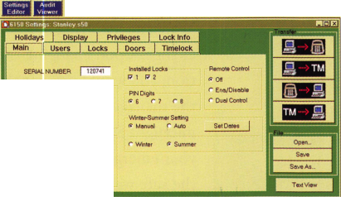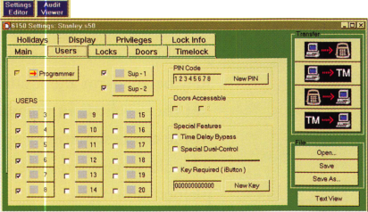

Eile Configuration Window Help

■Klffl 1 &\w\ ?[

|  |  |
| --- | --- |
| pnnnRnjM |  |
|  |
| 1 Holidays | Display |

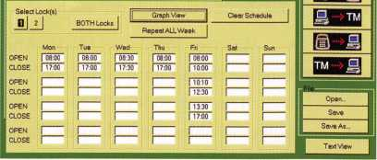

The time lock screen allows you to set up a repeating weekly time lock schedule with up to four locking periods per day. You can also select one or both locks to be time locked. The short close and long close features override the time lock schedule on a one time per use basis.

Eile Configuration Window Help

-ftiffl I aH ?|

Another item to keep in your tool kit is an adequate supply  
of wire ties and tie blocks. Wherever a cable plugs into  
anything, use a block and tie to secure it just before the

connection so  
that an unguided  
cash register  
drawer won’t  
unplug it. Just  
because a cable  
connector snaps  
into place with a  
positive lock  
doesn’t mean a  
typical 18-year-old  
fast food manager  
can’t propel that  
cash drawer with  
enough force to  
dislodge it.

Here’s a tip for  
users of self-adhe-  
sive wire tie  
blocks: They only  
stick if the surface  
they’re being  
attached to is  
clean. Use a paper  
towel with a little  
rubbing alcohol  
on it to wipe  
down the target  
surface. It only  
takes seconds to  
dry, and it will  
remove any greasy  
film quickly.

The installations  
shown here have  
shortcomings that  
would keep me  
awake at night.

That’s all I can say about them without hiring someone to  
start my car for me.

I don’t believe in confronting a customer with every bell  
and whistle a lock possesses. It’s confusing, and it tempts

After you’ve set a time lock schedule, you can view it graphically for a clear view of periods when the safe can be opened and when it’s time locked.

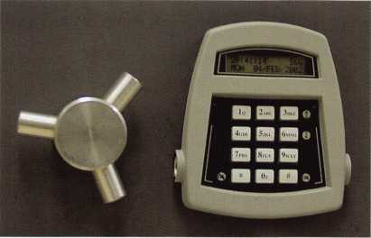

The 6150 keypad display reverts to time and date information when it’s not being used for programming or code entry. Who needs a wristwatch?

the customer to enable features that only serve to make his  
life needlessly complex. The better approach is to let the  
customer explain his needs to you, then select the lock fea-  
nHHm tures that meet those needs. Just because a lock has  
a particular set of features doesn’t mean it’s manda-

tory to try and use them all in every application.

Use whatever fits the situation.

With that in mind, here’s some of what the 6150 has  
to offer:

* (1) Programmer Code—The holder of this code  
  cannot open the lock, but can perform all program-  
  ming functions that can be initiated from the key-  
  pad. That includes uploading and downloading  
  information via the Dallas Touch Key system.
* (2) Manager Codes—These code holders can per-  
  form some of the programming functions and can  
  open the lock(s), but may be restricted under limita-  
  tions you set in the PC software.
* (18) User Codes—These code holders can change  
  their own codes, but that’s about it for program-  
  ming abilities. They can open the lock(s) within imi-  
  tations you set in the PC software
* Time Delay Bypass—Any code that can open the  
  lock(s) can be given time delay bypass capability,  
  meaning that the code can be used to open the lock  
  immediately, without first waiting for a programmed

time delay to  
elapse.

•Dual Control—  
Any code that can  
open the lock(s)  
can be required to  
have a second  
code holder also  
enter his/her code  
before the lock(s)  
will open. Instead  
of a second code  
holder (or in addi-  
tion to a second  
code holder), the  
user could be  
required to have a  
particular, previ-  
ously registered

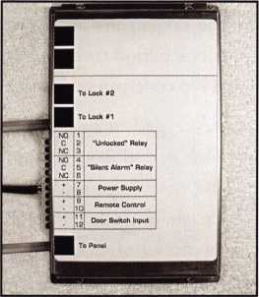

The control unit is housed in a sturdy metal case. Connections are clearly labeled. Note provisions for a remote control signal, duress alarm connection, and even a relay that can signal when either lock is unlocked.

Keynotes • March 2002

2

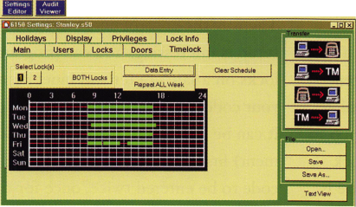

Dallas Touch Key that must be held against the keypad’s port. In this case, both the key and code would be needed to open the lock(s). A third alternative is to require a remote signal to the 6150’s control unit. Both the signal and the user’s code would be needed to open the lock(s).

* Duress—An alarm connection is required. Adding or sub­tracting 1 from the last digit of a code sends the duress signal while the lock appears to operate normally.
* Keypad Tamper Indication—Disables user codes and dis­plays a tamper message on the LCD if the keypad is removed, even if it has been carefully replaced. A manager code can be used to return the lock to normal function.
* Audit Trail—The lock records which code performed what function at any given date and time. The optional 6150 PC software is used to manage and store this valuable infor­mation. Audit trail download is via direct cable or Dallas Touch Memory.
* Time Lock—The PC software allows you to create a repeating seven-day time lock program. It can be different for each day of the week, with up to four different opening and closing periods per day. In addition, you can preset up to 20 holiday periods that will override the regular time lock program. One very nice feature of the time lock software is that it will let you examine your time lock schedule in a graphic format that makes it easy to see what you’ve pro­grammed. The time lock function can be applied to either or both locks in a two-lock application.
* Short Close—From the keypad an authorized code can set and start a short time lock period from 1 to 99 minutes, in single minute increments. No code can override a short close.
* Long Close—From the keypad an authorized code can set and start a long time lock period from 1 to 99 days. This period overrides any regular time lock programming that may be set in the lock. No code can override a long close. That means you need to be very careful when setting a long close. Like most other lock features, you can use the PC software to disable it; a wise thing to do if the customer doesn’t have a need for it.
* Time Delay—The PC software lets you designate a time delay period of 1 to 99 minutes and an opening window of 1 to 9 minutes, in single minute increments. Better still, if

you’re using two locks, you can set a different time delay and opening window for each lock. The time delay(s) can count up or down on the keypad LCD.

* Remote Control—Requires input of an outside signal (5 - 12 volts DC) at the control unit. This signal can be used as half of a dual control requirement, or it can be used to enable and disable the lock for use by the codes.
* Manager/Employee Mode**—You** can set the lock to disre­gard user codes until a manager’s code is used to enable the lock. The user codes will then function until a manager code holder disables the lock again. In addition, you can tell the 6150 to allow particular users to disable the lock. User code holders can never enable the lock.

These are some of the 6150’s features. Oh yes, there are more, and I’ll tell you how you can satisfy your curiosity shortly.

The way the control unit handles the locks in a multiple lock setup is interesting. You can program a user code to open the locks on a safe’s outer and inner compartment. If you enter your code and select lock #2 (inner compartment) to open, it can be set to automatically open lock #1 (outer compart­ment) first. Or you can program the lock to require the user’s code to be entered twice, once for the outer door and once for the inner door. The choice is yours.

**You** can even program the length of time each lock bolt stays retracted when a valid code is entered. The factory default period is 5 seconds, but it can be lengthened to 60 seconds if desired. All this is done in the PC software.

We’ve digested a lot of information about the 6150, but there is more. If you’d like a set of 6150 installation, operating, or software programming instructions, you’ll find them in Adobe Acrobat (PDF) format on S&G’s website ([www.sglocks.com](http://www.sglocks.com)). Just take the “Downloads” link at the bottom of the home page.

Access control has indeed come a long way since stone age man first thought of blocking the entrance to his cave to keep the bad guys (and and varmints) out. Like most technol­ogy driven industries, our progress has picked up speed in the last couple of decades, and the pace will only accelerate. It can be frustrating to try to keep up, but it can also be stimu­lating. Q



Keynotes • March 2002



**RING of a KING**

Name Members William P. Grant CRL 17

Recruited Evelyn V. Wersonick CML, CPS 16

Kwok-kei Leung 209 Joseph P. Ferrero CML 16

Toshihiro Asano 1 14 Gary F. Teams CPL 16

Henry W. Raymond 100 Kenneth E. Kim CRL 16

Yuriko Yanai 74 Michael E. Jordan Jr, CML 16

Stewart J. Levine CML 66 Brian J. Reetz 16

MaryS. Ohmit CPL 66 Robert C. Rodocker CRL 15

Charles C. Robertson CML 65 William J. McElheney CML 15

Jack Hobin CPL 51 Joseph W. Whitaker CPL 15

William B. Neff CML 48 Jon B. Griswold CML 15

Salvatore J. Dulcamara CML 40 Michael D. Robinson CRL 15

Myeong-Rae Cho 38 Russell P. Fuller CRL 15

C Allan Halverson 37 Daniel L. Landry Jr 15

Dana L. Barnum CML 35 James L. Hancock CRL 15

Barry K. Leas CRL 35 Leonard J. Passarello CPL 14

Danny W. Rudd CPL 31 James E. Gruber CRL 14

Larry A. Warnick CML 31 Paul M. Souber 14

Jeanne G. Lodge CML 30 James T. Brickler CRL 14

Breck H. Camp CML 28 Joseph C. Fuller CML, CMST 13

William Lee 28 Frank D. Hartung CML 13

Jim Williams CRL 28 Rolando Bouza 13

Lawrence F. Smith Jr, CML 27 Donald H. Shiles RL 13

James M. Watt CML, CPS 27 John A. Ilk CRL, CPS 13

Anthony J. Ramunno CML, CPS 26 Richard C. Sievers 13

John C. Elliott Jr, CML, CPS 26 Eugene R. Altobella Jr 1 3

Marian M. Swann CRL 26 Ernest W. Wright 12

Jeffrey S. Nunberg CML, CMS 26 Raymond C. Lusk CML 12

J Thomas Hood CML 26 John F. Engel CRL 12

Eugene R. Altobella Sr 26 Eric F. Veal 12

Japies H. Glazier Sr, CML 25 Thomas J. Demont CML, AHC 1 1

Robert F. Carroll CPL 25 Basil W. Shannon CPL 1 1

Robert H. Stafford CML 25 William J. Wickward CML 1 1

Robert D. DeWeese CML 24 Calvin G. Harris CML 1 1

Michael B. Groves 24 Herbert C. Dusenberry CML, CPS 1 1

Jerome L. Cohen CML 23 Timothy K. Chow 1 1

Peter K. Gauthier CPL, CPS 23 Dale L. Knowles CPL 1 1

Elvis D. Hammerschmidt CPL 23 Alvin N. Minor 10

Man-Soo Seo RL 23 Gene Eldridge CPL 10

Diana R. Barnum CRL 22 Ronald P. Riggins CML 10

James J. Cawby CML, CPS 22 Lester S. Brodsky 10

Philip A. Rovenolt CPL 21 Larry L. Votaw CML 10

Robert W. Duman Sr, CML 20 Thomas R. Smith CPL 10

-. John L. Shandy CML 19 Todd K. Ladwig CML, CPS 10

John S. Dorsey CML 19 William T. Straub CML 10

D Michael Lee Sr, CPL 19 Richard T. Johnson CPL 10

Keizo Takahashi CRL 18 Robert M. Massard CRL,AHC 10

James E. Fowler Sr, CML 18 Dale V. Crosby CPL 10

David C. Harris CML 18 Marian E. Sagar 10

Walter W. Lascar RL 17 James V. Hawley CRL 10

Peter R. Hall 17 Takashi Kuwana CRL 10

Thomas G. Vandersteen CML, CPS 17 James Bright 10

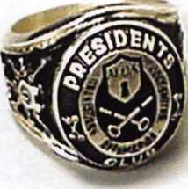

How can I join the President's Club?

You can earn a membership in this prestigious club by recruiting  
just 10 new members for ALOA.

*Any ALOA member may participate.

What do I get?

When you recruit 10 members, you receive a handsome blue blazer with a President's Club crest. For each addi­tional five members you recruit, you receive a lapel pin with gold-filled numbers, indicating, your recruiting suc­cesses.

You also get the satisifaction of knowing that you are  
helping your association, helping your industry grow,  
and you are helping fellow locksmiths achieve success.

How do I get started?

Mail the form below to the ALOA office for a supply of  
applications (800) 532-ALOA or FAX (2 1 4) 827-1 8 1 0.  
One President's Club credit is awarded for each new  
applicant. Credit is awarded only after the membership  
application is pproved. However, the credit will apply  
for the period in which the application is received.  
Failure to identify yourself as the sponsor on the applica-  
tion form at the time it is submitted to ALOA for process-  
ing will forfeit any credit.

o^TT.

Yes! I want to join the ALOA President's Club.

j Please rush me applications so I can start earning credit toward membership in the club!

Name

Company

Address

City State Zip

Mail this form to ALOA • 3003 Live Oak • Dallas, Texas 75204-6186

**2001 Mustang**

**Transponder Tutorial • • \***

by Jeff Trepanier, RL

There’s  
some-  
thing  
timeless  
about the  
Mustang.

Seems  
like it’s  
been  
around  
forever,  
and it’s  
still going  
strong.

Since the  
1960s, the  
Mustang

has seen some body style  
changes and mechanical  
updates as well. Let’s take  
a closer look at this mod-  
ern classic from a lock-  
smiths’ point of view.

3. The removed ignition cylinder. This view shows  
the spring-assisted retainer at the end of the igni-  
tion cylinder assembly. Remove the retainer by  
gently lifting up on the spring steel and pulling the  
retainer out from the U-shaped tabs. There is an  
access hole directly below the retainer. With the  
ignition plug turned as far as it will go, there will  
be a spring-loaded ball bearing under the access  
hole. A sturdy paper clip will push the ball bear-  
ing down enough so that you can continue to  
rotate the ignition plug for disassembly. Before  
you make this final rotation, cover the hole from  
the retainer that was removed so you don't close  
the ball bearing.

2. The ignition cylinder on the right side of the steering column. The steering column shroud need not be removed in order to get the ignition cylinder out. There is a poke hole already pro­vided in the lower column shroud. Whether you use a key or pick on the ignition cylinder, you need to go to the "on" position, push the retain­er and pull the ignition cylinder out.

I. I he key that came with  
the vehicle we're servicing.  
This key is equipped with a  
transponder, which starts the  
engine. Ford uses the eight-  
cut keys for most of its mod-  
els There are some  
that use 10-cut keys.

4. This is a view of the ignition plug removed  
from the ignition housing. Shown here are seven  
wafers opposing positions two through eight.  
Also, you can see the spring without the ball  
bearing near the end of the lock plug.

5. This is a top view of the plug. You can see the  
opposing wafers. To the right of the wafers is the  
key buzzer block, which can be easily lost if you  
are not careful during disassembly.

8. The two tools I like to use to remove the glove  
box lock plug. The tool near the top of the photo  
is a hook extractor; I find it works quite nicely  
for getting a hold on the lock plug in the key.  
The bottom tool is a hook pick that I use to push  
down on the bottom of the retainer to pull out the  
lock plug.

7. The glove box lock has three wafers in the  
plug, positions six through eight. This lock plug  
has what looks like a fourth wafer, but really is a  
spring-loaded retainer. This retainer is solid on  
the bottom so you can, push down on the retainer  
and gently pull the lock plug out. Some picking of  
the wafers may be needed to completely remove  
the plug. If the glove box lock is in the vertical  
position, it's locked. The lock plug can be  
removed at this time or picked in the counter  
clockwise position a quarter of a turn to the  
unlocked position.



Keynotes • March 2002

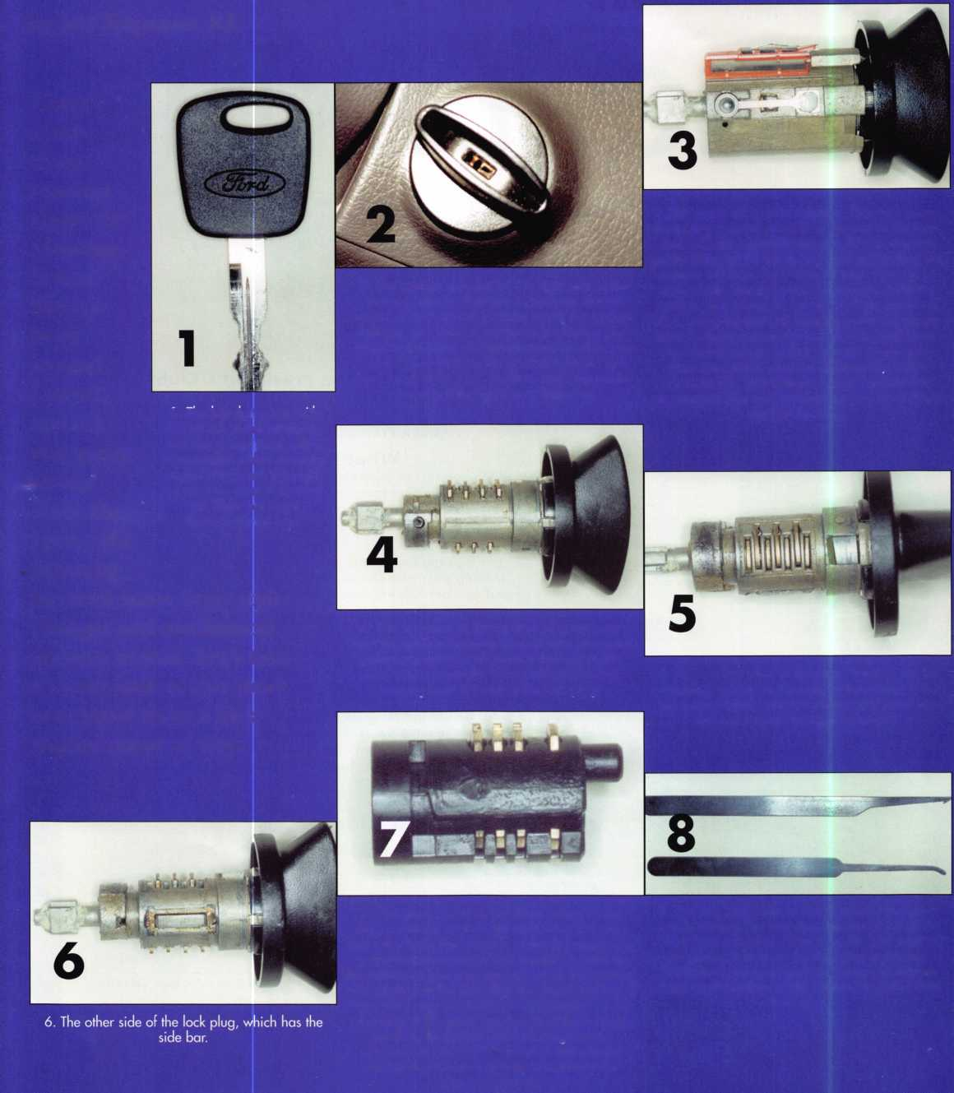

9. The driver's side door panel

tllillll

12. The underside of the panel. You need  
to remove the two Phillips screws, remove the  
wire assembly and unplug the mirror control  
wire assembly.

mam

10. The first step in the door panel removal. Gently pry at the top of the upper right hand corner trim. There is one spring clip that holds this piece in place, and it hooks in at the bottom of the trim.

11. The tab that needs to be gently pried out.  
There is a slot provided at the top center of the  
control panel assembly. Now the assembly can be  
moved for further disassembly.

13. The two Phillips screws that need to be removed. These screws are visible after the con­trol panel is removed. Not photographed is the plastic plug that helps hold the door panel onto the front edge. Gently lift up and pull the door panel away.

14. The door with door panel removed.

1. The inside of the door panel. There are nine panel hooks, which is why you pull up before you pull the panel away.
2. The door with the skin mostly pulled away. The black cable seen in the center is the door release cable. There is no rod anymore. Also seen here is the door lock rod.
3. The lock rod. 18. The door opening tool on the lock rod.

Using a door opening tool with the end hooked at  
a 90-degree bend. Go down about eight inches,  
hook the rod and pull up. Remember always be  
careful not to hook wires, etc.

19. Inside the door panel by the edge of the door. This would be a second choice for a door opening.  
You can use the handle part of a door opening tool like I did. All you need is a about a four-inch tool with  
a 90-degree bend. You need to go down about 14 1/2 inches and gently lift up at the bottom of the bell  
crank assembly. The door lock cylinder has a fixed tail and the doorlock rod (snown here at top) will not  
move. If you make contact with the door lock rod, the door lock button inside will move a little but not  
enough to unlock the door. You can see what is going on with an inspection light in the door to take away  
the guesswork and to avoid doing any unnecessary internal damage. It does not take much effort to unlock  
the door this way, so again, lift very gently. As always you want to avoid any wires as seen in this photo.

Keynotes • March 2002

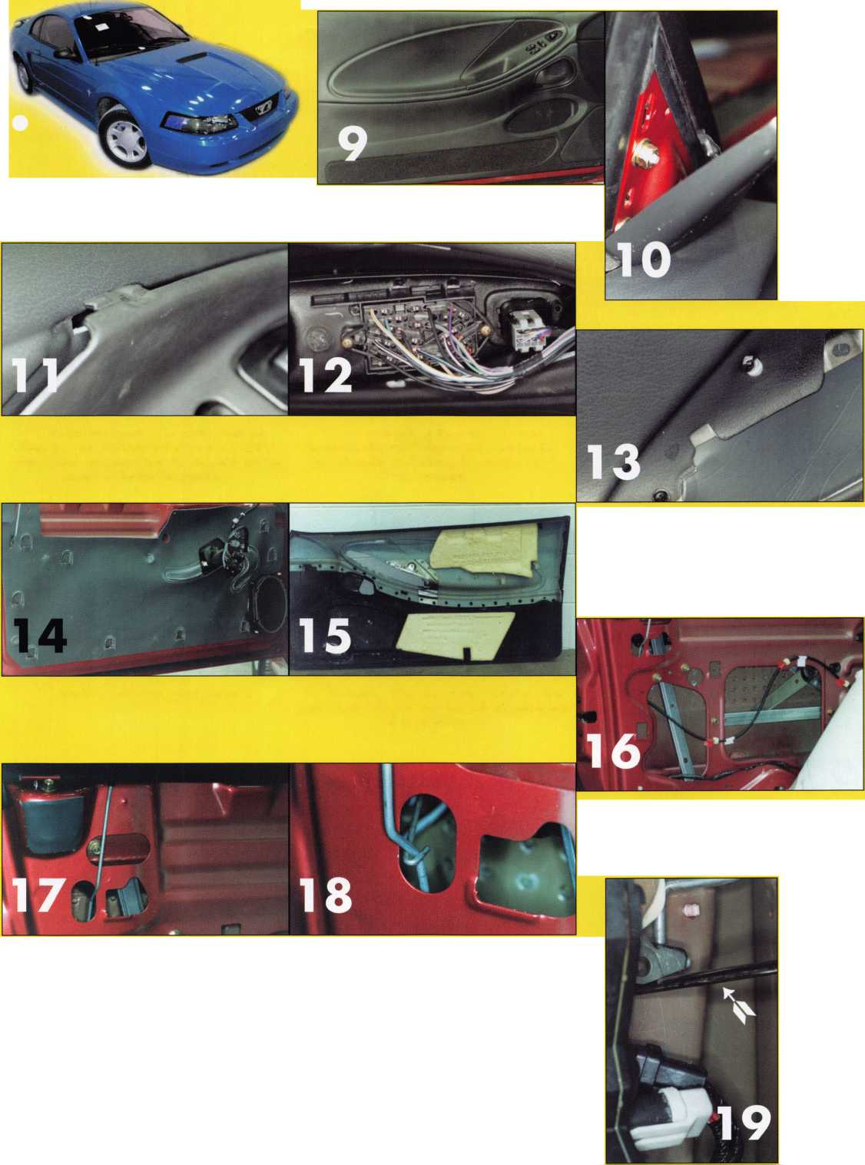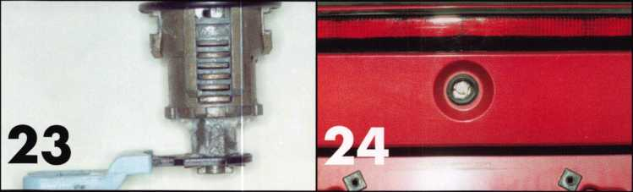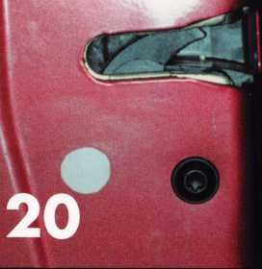

20. The approximate contact point  
would be inside the door indicated  
by the white dot.

This is an easy car to open, in my opin­ion. There are several ways you can make the mechanical key: EZ Reader, the Determinator, A-i ignition pick, remove the door lock, find the six cuts and progression the rest of the cuts, read the three wafers in the ignition, etc. No matter which method you use,

you should be able to have the vehicle done from start to

21. The same as photo 19 in the unlocked position. 22. The door lock cylinder on the lock rod. To

remove the lock, just slide it off.

finish in less than an hour.

23. The bottom of the door lock. Through the drain 24. The trunk lock,

hole, you can see six of the wafers in positions one  
through six.

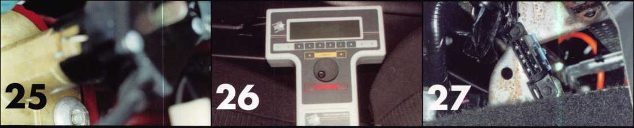

25. The single pop rivet holding in the trunk lock  
assembly (which has an electric trunk release).

I found it was not necessary to remove the trunk  
lock assembly because it was pop-riveted. Service  
the trunk lock only as needed.

26. The NGS tool on the driver's seat. So far you  
only need the one plug for all Ford, Lincoln and  
Mercury models.

27. This is where the converter is mounted.

It is located just above the carpet line over the  
transmission hump in the center and just behind the  
center console. The plug can only go on one way,  
so watch what you are doing to prevent any dam-  
age to your test equipment, or the vehicle.



Keynotes • March 2002

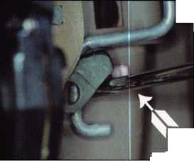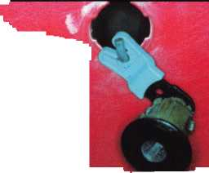

1. The second thing you see after you plug in. his will occur automatically after the initialization It will start at service bay functions. Press the button to the left or right of the word "trigger" to continue.
2. The next function. Scroll down to HEC-Hybrid Electronic Cluster. Press "trigger." The selections are different per make, model and year.
3. Next function. Scroll down to Security Access and press "trigger."

33. I usually see this screen when I forget to turn  
the ignition cylinder to the "on" position. If this  
happens, press cancel and you will return to the  
previous screen. Turn the ignition on and continue,

1. Next function. Scroll down to Mustang and press "trigger."

32. Next function. Wait a moment.

34. Next function. If you are successful, the  
screen shows "Access Delay: 10 minutes." If you  
have nothing to do for 10 minutes, you can play

, or in knowing your program-

1. This is what happens on the instrument cluster once you've successfully started the programming procedure. You will see "dlAG," which could be short for "diagnosis"?
2. Next function. Scroll down to Ignition Key Code Erase and press "trigger."

electronic Yahtzee, or in knowing your program­ming will be successful, you can write up the bill. You are not trapped or committed to the vehicle; you cqi get out and do other things, like make a trunk key if it is a two-key vehicle. Or, call the florist and send your wife flowers like I did.

(It was Valentine's Day.) You get the picture; you can do other useful things in 10 minutes.

FUEL DOOR ❖

38. The theft light on the instrument panel  
This light is used for programming  
additional keys.

1. Next function. Consult your programming procedure to program one or two keys, depending on the year and model. )ne of the places you can obtain programming information is from the dealership. Not all dealerships are locksmith friendly.

**LECT ITEM AND PRESS TRIGGER**

**town** cm

**ICCESS BELAY : 18 MINUTES**

|  |  |  |  |  |  |
| --- | --- | --- | --- | --- | --- |
|  |  | r-——^ | r—"~ | “ T~ ' 1 |  |
| $ | 6 |  | A  o  m | fijl | 5 |

|  |  |  |  |  |  |  |  |  |  |  |  |  |  |  |
| --- | --- | --- | --- | --- | --- | --- | --- | --- | --- | --- | --- | --- | --- | --- |
|  | l 4 ; |  | 6 |  | 8 | WmB f W l 1  1 4 |  | 6 |  |  | HHi SfeJB | $ | a | 8 |
|  | | | | | |  | | | | | ■ ■ | | | |

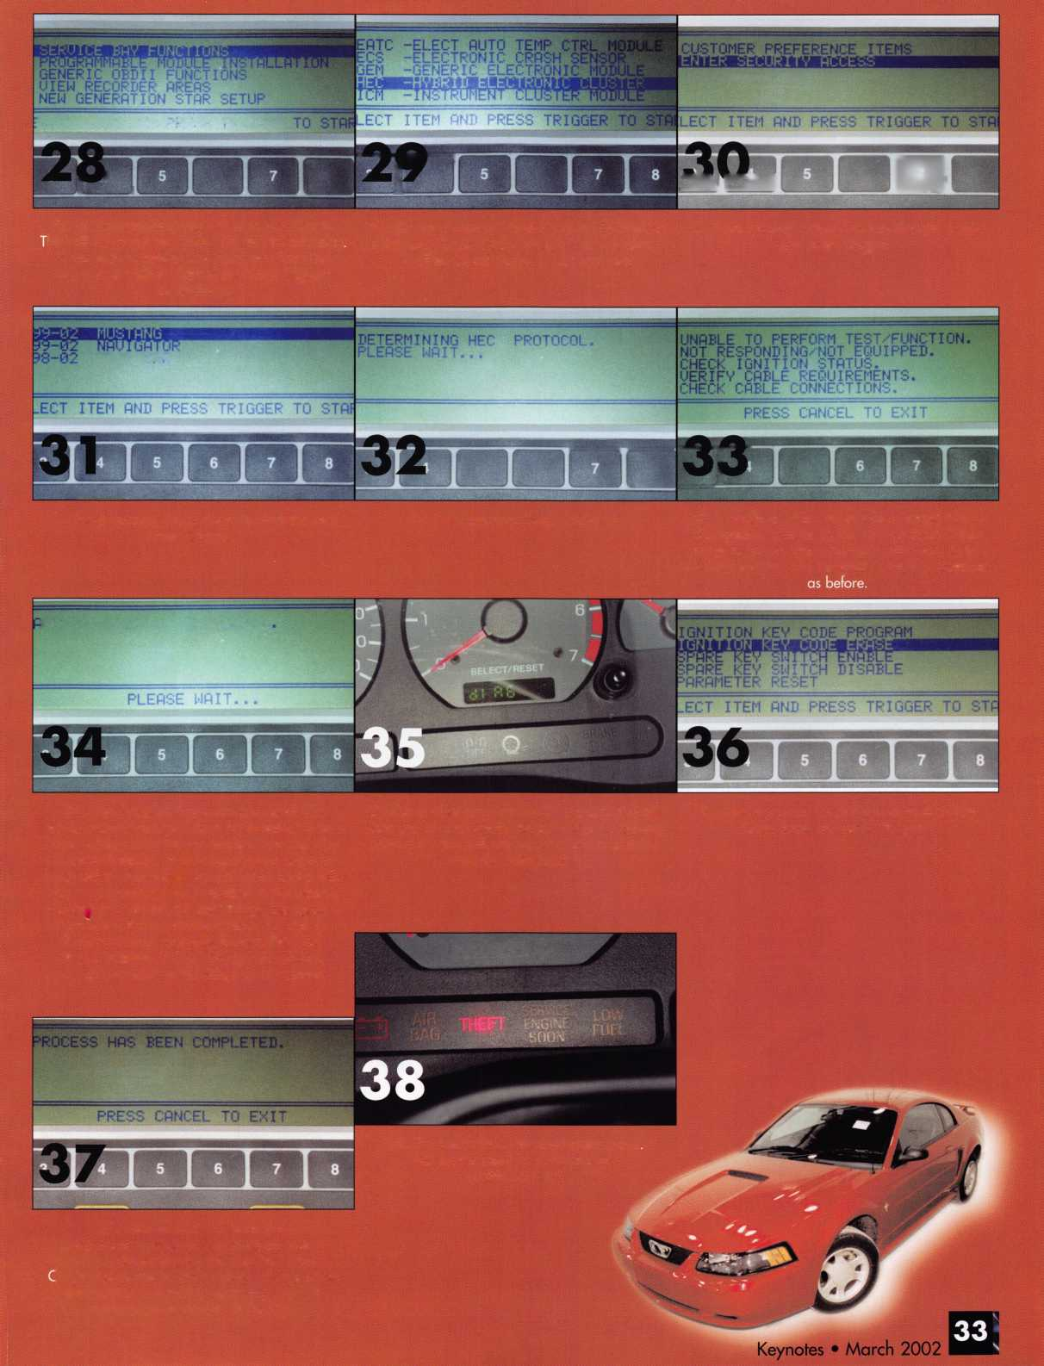

GET READY TO

ROCK N’ ROLL IN RENO

FOR SAFETECH 2002

Top-notch classes and exhibits aren't the only reasons to go to SafeTech 2002. Reno itself offers as many reasons to go as you can count. SAFETECH is heading west to Reno/Lake Tahoe for the 2002 Annual Convention, April 8-13, 2002. You won’t want to let this one roll by. Reno/Lake Tahoe attracts everyone from the businessperson looking for a premiere golf course, to the avid skier looking for the steep and deep, to the weekend high roller. Travel experts, Rand McNally, have named Reno/Lake Tahoe as the number one resort destination for outdoor recre­ation in the U.S. And it is easy to see why. Even if you don’t ski, you can still choose from a variety of things to do such as sailing, fishing, kayaking, mountain biking or rock climbing, just to name a few.

Booomtown Fun Center

NIGHTLIFE

Reno/Sparks/Lake Tahoe is known for its natural beauty, but this place  
ROCKS at night!

Reno is the birthplace of Nevada gaming. You can sit down at craps,  
blackjack or roulette tables, or drop quarters into slot machines and  
gamble all night long. But if you don’t want to listen to the jingling of  
money in your pocket, then there are a variety of entertainment options  
to choose from. Reno attracts some of the world’s biggest names in the  
entertainment industry such as Kenny Rogers, Tony Bennett, and Trisha  
Yearwood that perform here throughout the year.

SIGHTSEEING

If world-class skiing, gaming and golf aren’t enough, make sure to give your-  
self time to explore the rich history, cultural attractions and abundant  
shopping of the Reno/Sparks/Lake Tahoe area. Reno has the National  
Automobile Museum, The National Bowling Stadium and Fleischmann  
Planetarium. It also has a seasonal outdoor ice skating rink right down-  
town. For an ample taste of the “Old West”, visit Virginia City, the historic  
silver mining town only an hour from Reno. Another unique venue is the  
Ponderosa Ranch, the real location of famous TV series “Bonanza” and  
home to the legendary Cartwright Family, which will be the location for  
this year’s “SAFETECH Dinner Event”. Put on your boots and come along  
for the ride for an evening filled with Wild West entertainment, fun, and

some good grub.

EXHIBITORS

A & B Safe Corporation  
Clark Security Products  
“Dave McOmie, NSO”

Defiant Safe Co. /ARFE  
Kaba Mas Corporation  
La Gard Inc.

LA Safe and  
Lockmasters, Inc.

MBA-USA, Inc.

MDS Incorporated Meilink/Fire King Mutual Safe Co.

Phoenix Safe International Sargent & Greenleaf, Inc. Strong Arm Security, Inc. Timemaster, Inc.

TJ Tool Designs TMI, Inc.

DON’T MISS THE RIDE OUT WEST! • April 8-13, 2002!

Idlewild Park

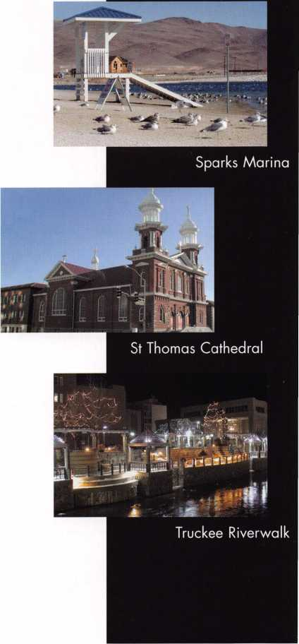

Keynotes • March 2002

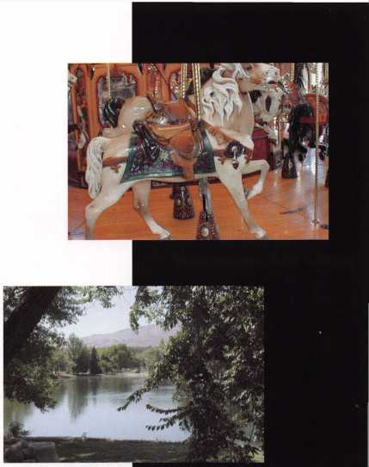

j,sYs>/"s *'M#*

*jfYYY&Y*

*y/*

i)/ >v

^ V/*/**/£?>>' /s< /‘...'s', ac*

*yj-yieXaYt\** >< *\*f6y6>(«07ft ■'/trsr/fj£*

^ ... . Ys .... -sy. v/ - *

^ ^ *<* » f'*'!? 'fr* L

*/t/is/yy ix> r, Y/ es* ej/>'/ ftfc iyS>* <*^v* *Yisf'y Y^ ^ •*■' " <\** >/ *Y:>*

*‘l t^Yt <.€'/, ///as+/ J t'■<* >' 'tt<+OS%, J>f*Ste. SY,s>'f txp*

*Y* *<i* * *-Y Ic>AiYk. /rlC 'J ~r>i* < *(lYssyp Yoy*.y *yy* j, *tt-iS~*

*,* f ^ ^ yj *\*sYC'> • X S*r •<■>*/ SY*. l>*

t/-,

, *f* / <r/ *tywyvratsr\** y*.e *y's'rsx -r* £7"a» o-/ <* *fsryts-caJi pX cy f'AC* t.'yt 4*

*Syt* . */fettxxx.'tt-c.A Y sft^tx Y.* *>—Yyyyrxutt Ye ct- sYi’l. s'# o/Yt> S s+* A. x$s Yeti*

X$- • .* . - ^ >• - -

«-—<V-

">» » *YlcXy* /fs Y^ceXaSYytys*

*4iXt*.,'t\** -

#yy*p

YY:r-<*~- 'eW*Yoy/if ... . —, ««<*/<** />><, '<*"* '>

y *Y^tZ^yt Yi+J? eSYny YYYx^ A Y* *><jL* Y YYc.*

/U^-C *^aYcm.S'Sxt^a/Sck^J'&Le*' Y / ^ ^Y ee ny/ txmY^*

*Yjjf'. flat*/ eyf,*-*+. /C^YYy^ ,s‘/f'YY~~ tAsvi eS Jf~eats>* cm ty* M^yi^/yf *<utLf S/a*

Jv / *'Ylo <■* v *est-sY*'” Y >,<* /Y« xY^*

*$/L»~s$y$4. cY>YYe4 ,oY/Y <>a*

W *YeecYYt*^ ■' t’f c* r Yt^r\** c*~t^. *4-x YY'yfy /£*

y , *,■?*■< A/Sy e/z&juY Y# %t /£•? c*~S* W /#»

■ y"> c. / ^ >'’/' ’ ./ y

/ ^?Ky.n. 4t4 ^seaSTE

rP ^-r' i^rcti*- ct-f i

*rx<£ sY' c> *4Z sY') °x & *y* * ^ ^

*-YoxxlS~'*

*'TXCO A'A^ d/Y ,nl* —<- '?* * *si'y* tyc,4 l4j /x^j,*

*Y^xYa (y^Y£*^*«Yu*+ *Y Y^<^Jyty4;YjY'xYtmAt'^^*"*

^>4r ^ stfamYZ ^ P c/ . V ^

*Yy^er~r*' Y^sm ert*/~<A.e tyt4.ci4, yt •Ykm^ mA<- /< Y* *.c4^ ac*0*1 ^

*/v^7 < ***/ixY Yi eY cuY^Y.4 tiYl "'^~J/ yxAyyY***'' ^« ^O ***x^Ysr /Y^xYxXkxpf***

*X > / % Ol y* ^ *CsYot tiCJit  
<Y^'* . t*/y^

*AitY***.\** . > *i.*st*Y 4 AujYS t-yt > '*m.'>i-6* ,

*^ /TY , s Ss s*

*C C-it '- *>"*■<■ ^* —>?— - w-v . - —^

^ *Y?ar*L^ < 'jf<y-t*. <Y */"*

*ZJX-X* 0"V»'-». *-.YYYa Y*a*

t*.y» »1^ ^><-‘ *n *l* ; S ^6.>» */Y\^yY'Y't czY/YL y& >> ><* y*

*Y/~/0crv/&«.£*&. /rf> /rYY Yjf* ' *s.'.. XSj.* -

* y/ > -

*/^'r^/YTa.SBSA. /SS &&"* y? ™'* M.,

*Y/[^* /^r *<yYYZS SY-*-i''yt Ym> sic. <Ylx YYY-r'yt xYt e. j Y*

***t****3****c c -%yyr Ye~<Y *n9* Y/\ a^yx* «. *')^4u^Yasa,4ya. i%y***

*Y

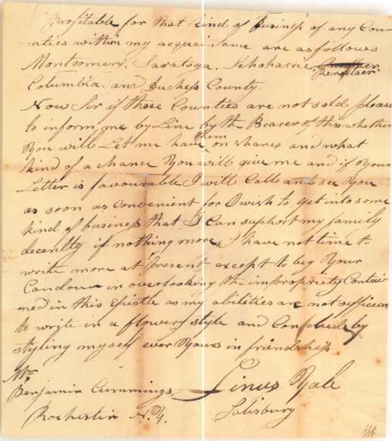

Linus Yale Letter  
Turns Up

by A.J. Hoffman, CML

Where would the lock business be if Linus Yale, Sr. had been successful in his farming equipment business?

Bizarre question? Not really, when you consider an authentic letter from 1823 that I just added to my col­lection of locks and industry memorabilia.

The pin tumbler cylinder as we know it today was the 1865 patent invention of Linus Yale, Jr., who was three years old when his father wrote this letter. Junior probably wouldn’t have been in the lock business if it weren’t for his father, and his father probably wouldn’t have been in the lock business if this letter had brought him success.

Linus Yale, Sr. was born in 1797 in Middletown, CT.

As written by Tom Hennessy in his book, Locks and Lock Makers of America, Yale was a man of rare mechanical talent and the curiosity of an inventor. He moved to Salisbury, NY, where he wrote this letter at the age of 26. He later moved to Utica, NY, where he and a man named Curtiss received a patent for a threshing machine in 1833.

In 1835, he received his second patent, this time for a saw mill. Later, he moved to Springfield, MA, where he learned lock making and received early patents for pin tumbler locks. One famous one was his 1844 patent for the Quadruplex bank lock, a lock with four rows of pin tumblers. I have one of these locks and a couple of keys in my collection.

Keynotes • March 2002

Linus Senior left Springfield in 1847 for Newport, NY, where he started the Yale Lock Shop. Linus Junior went to work in his father’s shop and received his first lock patent in 1851. After his father’s death in 1857, Junior moved to Philadelphia where he started the L. Yale, Jr. Co. making high quality bank locks.

In 1851, he moved to Shelburne Falls, MA, to join Col. Halbert Greenleaf to form a bank lock company known as Yale & Greenleaf, which only lasted a few years. Greenleaf moved to Rochester and formed another successful bank lock compa­ny with James Sargent - that’s right, Sargent & Greenleaf!

We mainly know Linus Yale, Jr. for his 1865 patent, which has gone down in history as the most significant development in locks to date: the pin tumbler cylinder. While his father had made pin tumbler locks, it was Junior who made the screw-in cylinder for a mortise lock. It could adjust for door thickness easily by how far it was threaded in. Furthermore, it used a small flat key called a feather key because of its innovative light weight. Remember, everyone was using bulky bit keys at the time!

So to paraphrase the open­ing of this article, what would be today’s standard run-of-the-mill lock and key if Yale’s father had made his fortune in farm­ing equipment instead? Not only that, but where would bank locks be with­out the significant early inventions of Linus Junior and Senior, not to mention the Sargent & Greenleaf connection?! Q

Mr. Benjamin Cummings  
Rochester, NY

Dec. 28th 1823

Dear Sir

I would inform you that I have built a machine on your plan which appears to work very  
well except the separation of the grain and straw which part I cannot make work to per-  
fection as yet. I wish you to write me some directions respecting that part. The encourage-  
ment in this town does not appear to be great as it is not much of a grain country.  
However I think I may be able to dispose of two or three perhaps in this town by building  
the machines myself and selling them cheap enough to suit the buyers. I shall endeavour  
to get enough at any rate to pay you for the right and bear my expences to see you early  
in the spring if not before.

I should like to get into business with or for you either in building the machines or selling  
the rights. I would be pleased to take two or three or more counties of you on shares to  
sell; as I well recolect you told me last winter you was about tired of traveling in the busi-  
ness. I should like to take this further off your hands and I presume from the short  
acquaintance we have had and the friendship which I trust subsists between us you will  
feel disposed to give me a good chance. I will come to you if you require it well recom-  
mended for honesty sobriety and skill in transacting business and think I shall be able to  
make it profitable to both you and myself in selling the rights. The counties which I am the  
most acquainted with and which I think to be the most profitable for that kind of business  
of any counties within my acquaintance are as follows Montgomery, Saratoga,

Schoharie, Rensselaer, Columbia and Dutchess County.

Now Sir if these counties are not sold please to inform me by line by the bearer of this whether you will let me have them or shares and what kind of a chance you will give me and if your letter is favourable I will call and see you as soon as convenient for I wish to get into some kind of business that I can support my family decently if nothing more. I have not time to write more at present except to beg your candour in overlooking the impropriety contained in this epistle as my abilities are not sufficient to write in a flowery style and conclude by styling myself ever yours in friendship

Linus Yale Salisbury

Keynotes • March 2002



All bills that saw movement between 01/01/2002 and 02/08/2002 ILLINOIS HB3856

CALIFORNIA A143

Requires locksmiths to be a licensed contractor or to maintain a $250,000 liability insurance policy. Provides that a violation of the laws regulating locksmiths is a crime.

STATUS: 01/07/2002: From Assembly Committee on Business and Professions with amendments

01/07/2002: Read second time, amended and re-referred to Committee on Business and Professions

* The current law sates that a locksmith must maintain a surety bond in the amount of $2,500.

FLORIDA SB964

Eliminates the local licensure category of registration and replaces it with the licensure category of local certification; expands the membership of the Electrical Contractors' Licensing Board to include local certified alarm con­tractors.

STATUS: 01/22/2002 Introduced

01/30/2002 In Senate Committee on Regulated Industries: Temporarily deferred

GEORGIA HB1082

Relates to electrical contractors, plumbers, conditioned air contractors, low- voltage contractors, and utility contractors; changes the definitions of utility contracting and utility system; changes a provision restricting the award of certain work to licensed utility contractors or those who intend to have the work performed by a licensed utility contractor.

STATUS: 01/18/2002 Introduced

01/1 8/2002 To House Committee on Industry

* Minor word change, no impact on low-voltage contractors

ILLINOIS HB3663

Amends the Private Detective, Private Alarm, Private Security, and Locksmith Act of 1993; provides that a person who applies for licensure as a locksmith agency between September 1, 2002 and December 31, 2002 shall be exempt from the examination requirement.

STATUS: 11/06/2001 Introduced

1 1/07/2001 To House Committee on Rules

ILLINOIS HB3748 / SB1558

Amends the Private Detective, Private Alarm, Private Security and Locksmith Act of 1993; makes a technical change to a Section concerning the leg­islative intent.

STATUS: 01/10/2002 Introduced

01/10/2002 To House Committee on Rules

* Minor word change, no impact on locksmiths.

Amends the Private Detective, Private Alarm, Private Security and Locksmith Act; makes a technical change to a Section concerning home rule preemp­tion.

STATUS: 01/22/2002 Introduced

01/22/2002 To HOUSE Committee on RULES.

* Minor word change, no impact on locksmiths.

MARYLAND SB 125

Continues the licensing and regulation of security systems technicians in accordance with the provisions of the Maryland Program Evaluation Act (Sunset Law) by extending to July 1, 2016 the termination provisions relat­ing to the statutory and regulatory authority of the Secretary of the State Police to license and regulate security systems technicians.

STATUS: 01/11/2002 Introduced

01/1 1/2002 To Senate Committee on Education,

Health and Environmental Affairs

* Renews the Security Systems Technicians Act which is set to expire this year. There is no definition in this law about what constitutes a "security system".

MISSISSIPPI S2482

Relates to the licensing and regulations of installing burglar alarms.

STATUS: 01/18/2002 Introduced

01/18/2002 To Senate Committee on Business and Financial Institutions 02/05/2002 Died in Committee

OHIO HB452

Creates the Commission on Electronic Security System Regulation in the Department of Commerce. Definition of Electronic Security System includes access control and CCTV.

STATUS:

12/11/2001

01/08/2002

01/22/2002

01/29/2002

Introduced

To House Committee on Commerce and Labor  
House Committee on Commerce and Labor:  
Heard Sponsor in Committee  
House Committee on Commerce and Labor:  
Heard Proponents in Committee.

PENNSYLVANIA HB2075

Regulates the licensure of electrical and alarm system contractors. Establishes the Electrical Contractors Licensing Board.

STATUS: 10/23/2001 Introduced

10/24/2001 To House Committee on Professional Licensure • While the definition of an alarm system does not include access control or CCTV, requirements to get a license include classes in access control and CCTV.

CHECK OUT ALOA'S WEBSITE AT <http://www.aloa.org/news/legcom.cfm>

FOR THE LATEST HAPPENINGS IN YOUR STATE



Keynotes • March 2002

TENNESSEE SB2087

Relates to the State Board for Alarm Systems Contractors.

STATUS: 01/14/2002 Introduced

01/17/2002 To Senate Committee on Government Operations

• Renews the Alarm Systems Contractors Act which is set to expire this year.

Copies of all these bills can be found at [www.aloa.org/news/legisla- tion.cfm](http://www.aloa.org/news/legisla-tion.cfm)

JOIN THE LEGISLATIVE ACTION NETWORK TODAY!

As we continue to expand our resources and become more competitive in the legislative arena, we need the monetary resources to match our successes. You can help with as little as $24.95 to the Legislative Fund. This is only the minimum that we are asking, and encourage you to give more if you can. Those that contribute will be given a Legislative Action Network Member kit to use in their grass roots efforts. Members who donate $100 or more become Legislative Action Network Council mem­bers, and enjoy the following extra benefits: a reserved place of distinc­tion on the special LAN Council; Discounts on ALOA bookstore items;

10 % rebate on all ACE classes; Complimentary Legislative Convention merchandise. Join today online at [www.aloa.org/news/lan.htm](http://www.aloa.org/news/lan.htm).

ALOA'S NEWEST CHAPTER IS INSTALLED

On January 6, 2002 ALOA celebrated the installation of its thirty-seventh and newest chapter: The Bi-State Chapter which encompasses Missouri and Illinois. Twenty-three attended in St. Louis, Missouri, the installation and swearing in of officers including North Central Director's Mark Blum, CML, CPS and John Soderland, CML, CMST.

John installed as officers, Kenneth Kim, CRL,  
President; Tom Raymond, Vice President; Jim  
Wisnewski, Treasurer, Tom Kirk, CML, Secretary;  
Ron Schwartz, Director; Ken Ahlheim, Director;  
John McClure, Director.

Chairman Kenneth Kim, CRL noted that, "he had  
the help and support of a number of people,  
including but not limited to, Jerry McNeary, Ron  
Schwartz, Scott Guetschow, Robert Theobald,  
Howard Wilder and Tom Raymond," in getting  
the chapter started.

"Some credit also has to be given to Ted Beishir,

Jr. While he wasn't instrumental in starting this  
chapter, he did make an attempt several years  
ago which did spark an interest among locksmiths  
in the area. Over the years that followed a num-  
ber of locksmiths continued to inquire about the  
possibility of starting a chapter," said Kim.

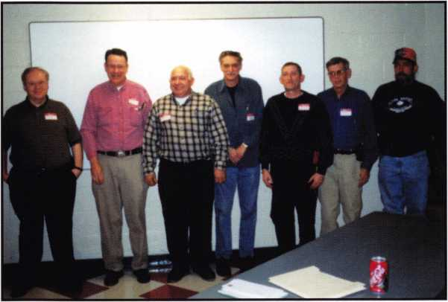

L-R: Kenneth Kim, CRL, Chapter Chairman; Jim Wisnewski, Chapter Treasurer; Tom Kirk, CML,  
Chapter Secretary; Ron Schwartz, Chapter Director; Ken Ahlheim, Chapter Director;

John McClure, Chapter Director; Tom Raymond, Chapter Vice Chairman

"My goal is, and always has been, to get as

many locksmiths involved in and represented by a local locksmith organization as possible. We believe that a chapter  
is the best way to achieve this goal and that is why we started a chapter," says Kim proudly.

Adds John Soderland, "I was proud and pleased to see the enthusiasm exhibited as the new chapter was chartered. This was a new generation coming of age in an ancient profession."

Established by the ALOA Board of Directors in 1985, ALOA chapters give members a way to participate more directly with the association's activities. Chapters allow members an opportunity to take advantage of more ALOA sponsored programs at the regional and local levels as well as help prepare those who have an interest in becoming an associa­tion and/or industry leader.

For more information on becoming a member of the Bi-State Chapter, contact:

Kenneth Kim, CRL, Chairman • 5524 Virginia Ave • St. Louis, MO [Kenneth@BatesStLock.com](mailto:Kenneth@BatesStLock.com)

63111 • 314-351-7252 • 314-351-7401

(fax)

Keynotes • March 2002

NEEDED

experienced, motivated, hard working technicians

team players. Great income potential. We offer paid

holidays, vacation, and medical. Don't delay, fax your resume

. Liberty Lock and Safe, FAX 702/876-5470 or

www. I i bertylock .com.

WANTED: EXPERIENCED PROFESSIONALS

Ready to take a step in the right direction? If you are an experi-  
enced security professional with strong sales skills, come join  
our team. We are a rapidly expanding 35-year-old business in

the beautiful Pacific Northwest. The ideal candidate would have  
a strong backgroung in commercial security and door hardware  
or electronic access control, CCTV and alarms. We will train the  
right candidate. We offer 401 (k), paid vacation, medical, new  
uniforms and a work environment that encourages growth and  
rewards those with dedication! Contact Paul Brandon at The  
Lock Shop toll free at 866/LOCKSHOP, or on the web at  
[www.lockguys.com](http://www.lockguys.com).

AUTO EXPERT WANTED

Looking for experienced car/auto locksmith. Great pay, paid vacation, bonus and education. Call 281/830-9441.

EXPERIENCED LOCKSMITHS NEEDED

Servicemen needed for road and shop work in the fields of commercial, residential, automotive, safes, and access control. Pleasant work environment, salary or hourly wages available. Paid vacation, holidays and medical benefits. Fax resumes to

SERVICE TECHNICIANS WANTED

Experienced, hard-working service technicians wanted. We offer paid vacation, holidays and medical. Call 781/324- 1600, or fax resumes to 781/321-2422.

BUSINESS FOR SALE

BUSINESS FOR SALE

Well-established lock and safe business for sale in the Midwest. Commercial property is located on the corner of a very busy intersection, has a two-bedroom apartment above shop and a full-service 7-car detached garage in rear. Property appraised for $95,000. Sale includes property, two fully equipped service vans, all fixtures, equipment, and inventory. Gross annual sales of $220,000. Employees will remain; owner available for tran­sition. Owner assisted financing possible. Call 815/654-0882.

LOCKSMITH OWNER RETIRING

Only locksmith in Montour County (North Central Penn. Area). Includes 24 ft. step van, tools, merchandise, many established accounts, key machines, computer with key codes, all inventory. Shop to be leased if necessary. Over 15 years in the same location. Unlimited potential. Will stay for smooth transition.

Call 570/275-3129.

313/563-3617, or call 313/563-6270.

Classified Advertising Policy

Classified advertising space is provided free of charge to ALOA members, and fora fee of $. 60 per word, $ 15 minimum for non-members. Classified ads may be used to advertise  
used merchandise and overstocked items for sale, "wanted to buy" items, business opportunities, employment opportunities/positions wanted and the like. Members or non-members wishing  
to advertise services or new merchandise for sale may purchase a "Commercial Classified Ad," for a fee of $1.30 per word, with a minimum of $40. Each ad will run for two issues. For blind  
boxes there is a $5 charge to members and non-members. All ads must be submitted in writing to the ALOA office by the fifteenth of the month, two months prior to issue date. Send to  
Keynotes Classifieds, 3003 Live Oak St., Dallas IX 75204-6186. ALOA reserves the right to refuse any classified advertisement that it deems inappropriate according to the stated purpose

of the classified advertising section.

J

Keynotes • March 2002



WANTED TO BUY/SELL

FOR SALE

HPC 1200CM Blitz code machine. Over 100 cards, two cutter wheels, manual and card book. Approximately five years old. Works great.

$1200 plus shipping/insurance. Call John at 203/397-3093, or e-mail at [amitylock@snet.net](mailto:amitylock@snet.net).

FOR SALE

Locksmith magazines published during 1974 to 1998. Keynotes, Safe & Vault Technology, Locksmith Ledger, Reed's Security Reporter, National Locksmith and others. Also, Beisser key machine, 5-inch cutters, ser #384, Beisser Key Machine Co., Detroit, Mich. Contact Charles Cameron, CML, 336/852-921 1 or e-mail: [ccameron@mail.com](mailto:ccameron@mail.com) for complete list and prices.

FOR SALE

Mobile locksmith shop - $4,000. Call 909/927-6858 for details. Retired ALOA member.

FOR SALE

"24" Segal Jimmy-proof vertical deadbolt locks #666 with model 7050 5-pin cylinders. (Clam-shell packed) MSRP 53.19@ $15. Take all paid by Visa/MasterCard. I will pay shipping in USA. Call W.H. Pulley at 217/824-8696.

Locksmith Training

Sponsored by Fox Uatley Technical College • 1825 n. Bluemound Dr. • Appleton, Ull 54912-2277

6-Day Program • Career Change in One Uieek • march 18-23,2002

This is a basic locksmithing training course sponsored by FVTC’s Security and Crime Prevention  
Department and conducted by ALOA ACE instructors. Designed for the locksmith shop owner

who would like to provide entry-level training for new apprentice locksmiths as well as those who would like to receive professional  
training that will enable employment with a professional locksmith. The course will allow the student to gain enough knowledge to  
make them a starting apprentice in an existing shop. Job placement locations will be made available at the time of the class.

To maintain quality the course enrollment will be capped at 12 students. Enroll early!

Curriculum includes:

Key Blank Identification and Duplication Key Codes and Code Equipment Basic master Keying

Lockset Seruicing, Functions, Finishes

Life Safety Codes

Lock Pick Opening Techniques

Pin and Disc Cylinder Seruicing Key Impressioning

Lock By-Pass Techniques Exit Hardware

Door Closers

Lockset Installation

Cabinet, Furniture, mailbox Locks

All tools and equipment will be made auailable for use during training. Class Hours: 8:30 am to 5:00 pm euery day Class Attire: Shop clothes Course Tuition: $995.00

http://unuu!.futc.edu/SecurityCrimePreuention/Locksmithing^20lndex.htm

Course Enrollment: See Linda Buck in the Criminal Justice Center

or call 920-735-2406

note: Enrollment deadline is Friday, February 15,2002



Keynotes • March 2002



A & B Safe Corporation

Phone: 800-253-1267 Fax : 856-863-1208 [www.a-bsafecorp.com](http://www.a-bsafecorp.com)

ADI Inc.

Phone: 516-692-1000 Fax 516-692-3457

Abloy Door Security

Phone: 800-465-5761 Fax 514-335-0430 [www.abloy.com](http://www.abloy.com)

Accredited Lock Supply Co

Phone: 201-865-5015 Fax 201-865-0030 [www.acclock.com](http://www.acclock.com)

Ace Lock & Security Supply

Phone: 908-688-7666 Fax 908-688-2442 [www.acelock.com](http://www.acelock.com)

Action Hardware Inc.

Phone: 800-662-6695 Fax 800-930-2329

Adams Rite Mfg Company

Phone: 800-872-3267 Fax 800-232-7329 [www.adamsrite.com](http://www.adamsrite.com)

Adesco Safe Mfg. Company

Phone: 800-821-6803 Fax 562-408-6427 [www.adesco.com](http://www.adesco.com)

Adrian Steel Company

Phone: 800-677-2726 Fax 517-265-5834 [www.adriansteel.com](http://www.adriansteel.com)

Alarm Lock Systems Inc. .

Phone: 800-252-5625 Fax 516-789-3383 [www.alarmlock.com](http://www.alarmlock.com)

Allstate Insurance Company

Phon: 847-402-8196 Fax 847-326-7509 [www.allstate.com](http://www.allstate.com)

American Lock Company

Phone: 708-534-2000 Fax 708-534-0531

American Security Products

Phone: 909-685-9680X1083 Fax 909-685-9685 [www.amsecusa.com](http://www.amsecusa.com)

Andrews Wholesale Lock Supply

Phone: 717-272-7422 Fax 717-274-8659

BWD Automotive

Phone: 334-872-6524 Fax 334-874-6011 [www.bwdautomotive.com](http://www.bwdautomotive.com)

Baldwin Hardware

Phone: 610-796-4012 Fax 610-796-4493

Boyle & Chase Inc.

Phone: 800-325-2530 Fax 800-205-3500 [www.boyleandchase.com](http://www.boyleandchase.com)

Buddy Products

Phone: 800-886-8688 Fax 312-733-8356 [www.buddyontheweb.com](http://www.buddyontheweb.com)

COMPX Security Products

Phone: 864-297-6655 Fax 864-297-9987 [www.nclnet.com](http://www.nclnet.com)

Clark Security Products

Phone: 800-854-2088 Fax 619-974-5284

Cook's Building Specialties

Phone: 505-883-5701 Fax 505-883-5704

Curtis Industries,

A Barnes Distr

Phone: 800-555-5397 Fax 800-867-6020 [www.curtisindustries.com](http://www.curtisindustries.com)

DETEX Corporation

Phone: 800-729-3839 Fax 830-620-6711

DORMA

Architectural Hardware

Phone: 717-336-3881 Fax 717-336-3500 [www.dorma-usa.com](http://www.dorma-usa.com)

DSC Group Of Companies

Phone: 905-760-3000 Fax 905-760-3040

Dire's Lock & Key Company

Phone: 303-294-0176 Fax 303-294-0198

Direct Security Supply, Inc.

Phone: 800-252-5757 Fax 800-452-8600

Don-Jo Manufacturing, Inc.

Phone: 978-422-3213 Fax 978-422-3467 [www.don-jo.com](http://www.don-jo.com)

Door Controls International

Phone: 800-742-3634 Fax 800-742-0410 [www.doorcontrols.com](http://www.doorcontrols.com)

Doyle Security Products

Phone: 800-333-6953 Fax 612-521-0166 [www.doylesecurity.com](http://www.doylesecurity.com)

Dugmore and Duncan, Inc.

Phone: 888-384-6673 Fax 888-329-3846

E. L. Reinhardt Co., Inc.

Phone: 800-328-1311 Fax 612-481-0166 [www.elreinhardt.com](http://www.elreinhardt.com)

ESP Lock Products Inc.

Phone: 978-537-6121 Fax 978-534-9109

Emergency Road Service Inc.

Phone: 888-839-5386 Fax 678-277-8105

Ewert Wholesale Hardware

Phone: 800-451-0200 Fax 708-597-0881

Fairway Supply, Inc.

Phone: 214-350-0021 Fax 214-352-4299 www. fa i r ways upply.com

Foley-Belsaw Company

Phone: 800-821-3452 Fax 816-483-5010 [www.belsaw.com](http://www.belsaw.com)

Fried Brothers Inc.

Phone: 800-523-2924 Fax 215-592-1255

H L Flake Co

Phone: 800-231-4105 [www.hlflake.com](http://www.hlflake.com)

H.S. & S. Wholesale Distrib.

Phone: 313-342-6777 Fax 313-342-7580

HES, Inc.

Phone: 623-582-4626 Fax 623-582-4641 [www.hesinnovations.com](http://www.hesinnovations.com)

HPC, Inc.

Phone: 847-671-6280 Fax 847-671-6343 [www.hpcworld.com](http://www.hpcworld.com)

Hans Johnsen Company

Phone: 214-879-1550 Fax 214-879-1530

Hardware Agencies, Ltd.

Phone: 416-462-1921

Hongtai Lock Co Ltd.

Phone: 137-238-1414 Fax 208-793-3856

Howard Keys

Phone: 704-509-4944 Fax 704-509-6248 www. howa rd keys .com

IDN Incorporated

Phone: 817-421-5470 Fax 817-421-5468

INTELLIKEY Corp.

Phone: 800-226-0703 Fax 321-724-0811 [www.intellikey.com](http://www.intellikey.com)

llco Unican

Phone: 252-446-3321 Fax 252-446-4702 [www.kaba-ilco.com](http://www.kaba-ilco.com)

Intermountain Lock & Supply

Phone: 800-453-5386 Fax 801-485-7205 [www.intermountainlock.com](http://www.intermountainlock.com)

Jensen Tools Inc.

Phone: 602-453-3169 Fax 602-438-1690

Jet Hardware Mfg., Co.

Phone: 718-257-9600 Fax 718-257-0973

Jo Van Distributors

Phone: 416-752-7249 Fax 416-752-3845

KABA High Security Locks

Phone: 860-621-3601 Fax 860-621-9727 [www.kabausa.com](http://www.kabausa.com)

KEY-BAK/West Coast Chain Mfg

Phone: 909-923-7800 Fax 909-923-0024 [www.keybak.com](http://www.keybak.com)

Knaack Manufacturing Co.

Phone: 800-456-7865 Fax 815-459-9097 [www.weatherguard.com](http://www.weatherguard.com)

LAB Security

Phone: 800-243-8242 Fax 860-583-7838 [www.labpins.com](http://www.labpins.com)



Keynotes • March 2002



LCN Closers/Div of Ingersoll

Phone: 815-875-3311 Fax 815-879-1497 [www.lcnclosers.com](http://www.lcnclosers.com)

La Gard Inc.

Phone: 310-325-5670 Fax 310-325-5615 [www.lagard.com](http://www.lagard.com)

Lockmasters, Inc.

Phone: 859-885-6041 Fax 859-885-7093 [www.lockmasters.com](http://www.lockmasters.com)

Locks Company

Phone: 800-288-0801 Fax 305-949-3619

Locksmith Ledger International

Phone: 770-886-0800 Fax 770-889-7703 [www.lledger.com](http://www.lledger.com)

Lucky Line Products, Inc.

Phone: 858-549-6699 Fax 858-549-3241

M. Zion Company

Phone: 212-349-8677 Fax 212-964-0495

M.A.G. Security

Phone: 714-891-5100 Fax 714-892-6845 [www.magsecurity.com](http://www.magsecurity.com)

MARKS, U.S.A.

Phone: 516-225-5400 Fax 516-225-6136 [www.marksusa.com](http://www.marksusa.com)

MARRAY ENTERPRISES

Phone: 408-970-0213 Fax 408-970-8767 [www.marray.com](http://www.marray.com)

MCS Communication Systems

Phone: 514-444-2040 Fax 514-444-2029 [www.mcscommunication.com](http://www.mcscommunication.com)

MMD, Inc.

Phone: 865-428-3611 Fax 865-453-4136

MUL-T-LOCK USA, Inc.

Phone: 800-562-3511 Fax 973-778-4007 www. mul-t-lock.com

Massglass & Door Service

Phone: 888-742-8837 Fax 818-991-5742 [www.massglass.com](http://www.massglass.com)

Master Lock Company

Phone: 414-444-2800 Fax 414-444-0322 [www.masterlock.com](http://www.masterlock.com)

McDonald Dash Locksmith Supp

Phone: 800-238-7541 Fax 901-366-0005 [www.mcdonalddash.com](http://www.mcdonalddash.com)

McManus

Locksmith Supply, In

Phone: 704-333-9112 Fax 704-332-8664

Medeco Security Locks

Phone: 540-380-5000 Fax 540-380-5010 [www.medeco.com](http://www.medeco.com)

Meilink Safe Company

Phone: 800-634-5465

Fax 800-896-6606

[www.fireking.com/products_Meilink](http://www.fireking.com/products_Meilink)

Monaco Lock Co.

Phone: 800-526-6094 Fax 800-845-5625 [www.monacolock.com](http://www.monacolock.com)

NKL Industries Inc.

Phone: 800-528-9900 Fax 757-485-0271 [www.nklindustries.com/products_NK](http://www.nklindustries.com/products_NK)

Omaha Wholesale Hardware

Phone: 800-238-4566 Fax 402-444-1664 [www.omahawh.com](http://www.omahawh.com)

Professional Business Products

Phone: 800-258-6219 Fax 813-888-5393

ROFU International Corp

Phone: 800-255-7638 Fax 253-922-1728 [www.rofu.com](http://www.rofu.com)

Rutherford Controls Int'l Co

Phone: 757-427-1230 Fax 757-427-9549 [www.rutherfordcontrols.com](http://www.rutherfordcontrols.com)

STRATTEC Security Corp.

Phone: 414-247-3333 Fax 414-247-3329

Sargent & Greenleaf, Inc.

Phone: 606-885-9411 Fax 606-885-3063 [www.sglocks.com](http://www.sglocks.com)

Sargent Manufacturing Co

Phone: 203-562-2151 Fax 203-776-5992

Schlage Lock Co

Phone: 719-264-5300 Fax 719-264-5382 [www.schlagelock.com](http://www.schlagelock.com)

Schwab Corp

Phone: 765-447-9470 Fax 765-447-8278 [www.schwabcorp.com](http://www.schwabcorp.com)

SecureRite.Com

Phone: 800-241-3930 Fax 858-974-5269 [www.SecureRite.Corn](http://www.SecureRite.Corn)

Securitron Magnalock Corp.

Phone: 775-355-5626 Fax 775-355-5636 [www.securitron.com](http://www.securitron.com)

Security Distributors Inc.

Phone: 800-333-6953 Fax 612-524-0166

Security Door Controls

Phone: 805-494-0622 Fax 805-494-8861 [www.sdcsecurity.com](http://www.sdcsecurity.com)

Security Solutions

Phone: 405-376-1600 Fax 405-376-6870

Sentry Group

Phone: 716-381-4900 Fax 716-381-8559 [www.sentrysafe.com](http://www.sentrysafe.com)

Sentry Security Fasteners

Phone: 309-693-2800 Fax 800-693-2872

Somerset Security Products

Phone: 800-881-5206 Fax 800-206-9949

Southern Lock and Supply Co.

Phone: 727-541-5536 Fax 727-544-8278 [www.southernlock.com](http://www.southernlock.com)

Stone & Berg Wholesale

Phone: 800-225-7405 Fax 800-535-5625

Sully Tools Inc.

Phone: 703-689-3416 Fax 703-787-0869 [www.sullytools.com](http://www.sullytools.com)

SunSafes Manufacturing Co.

Phone: 823-194-59300 Fax 823-194-59400 [www.eaglesafes.com](http://www.eaglesafes.com)

Taylor Security & Lock

Phone: 301-948-7670 Fax 301-948-1029 [www.taylorsecurity.com](http://www.taylorsecurity.com)

Taymor Industries, Inc.

Phone: 800-388-9887 Fax 800-288-8133

The Locksmith Store Inc.

Phone: 847-364-51 1 1 Fax 847-364-5125 [www.locksmithstore.com](http://www.locksmithstore.com)

The National Locksmith

Phone: 630-837-2044 Fax 630-837-1210 [www.thenationallocksmith.com](http://www.thenationallocksmith.com)

Timemaster Inc.

Phone: 888-798-8465 Fax 800-798-8463

Top Notch Distributors, Inc.

Phone: 800-233-4210 Fax 800-854-4146 [www.4topnotch.com](http://www.4topnotch.com)

Trine Access Technology

Phone: 718-829-2332 Fax 718-829-6405 [www.trineonline.com](http://www.trineonline.com)

U.S. Lock Corp.

Phone: 800-925-5000 Fax 800-338-5625 [www.uslock.com](http://www.uslock.com)

Videx Inc.

Phone: 541-758-0521 Fax 541-752-5285

W-LOK Corporation

Phone: 616-355-4015 Fax 616-355-4295 [www.wlokcorp.com](http://www.wlokcorp.com)

Webster Safe & Lock Co., Inc.

Phone: 901-332-2911 Fax 901-332-2878 [www.webstersinc.com](http://www.webstersinc.com)

Yale Security Group, Inc.

Phone: 800-438-1951 Fax 800-338-0965

Keynotes • March 2002

back page

About the Authors

A.J. Hoffman, CML is a recognized authority on cylinders and keying. He  
has served several terms as a member-at-large to the ALOA Board. In  
1988, he was inducted into the Locksmith Ledger Security Hall of Fame. In  
1992, he received the coveted Philadelphia Award. He is currently the  
Product Manager for Cylinders and Key Systems for both Schlage and  
Falcon Lock, divisions of Ingersoll Rand. He has held similar positions with  
Kaba and Corbin Russwin.

Greg Perry, CML, CPS has been in the locksmith industry for 19 years.  
He’s spent half of that time as a field technician for Security Engineering in  
Ridgecrest, CA. Greg is also a past president of the Desert Counties  
Chapter of the California Locksmiths Association.

Don Seburg is the Director of Security for Independent School District  
#279 in Brooklyn Park, MN.

Jeff Trepanier, RL is a noted expert on automotive locksmithing who has  
been published in various trade journals in the past. He serves as a man-

ager at Inter State Lock  
Masters in Racine, Wl.

Brian Costley, CML, CMST

was the 1995 ALOA (ALOA  
Lifetime of Outstanding  
Achievement) Award winner  
who has been involved with the  
security industry for over 25  
years. He has contributed to a  
variety of trade publications  
and is the director of Customer  
Services for Sargent and  
Greenleaf.

William Boyd IMeff, CML has

been in the security industry  
for over 25 years and is presi-  
dent of Neff’s Safe Lock &

Security Inc. in Lancaster,

Pennsylvania. Bill has taught  
various classes throughout the  
United States to the security  
industry. He is a certified  
ALOA Ace and Mas Hamilton

instructor and also a contributing editor for Locksmith Ledger. Bill was the  
first Certified Master Locksmith in PA and is recipient of the 2000 ALOA  
ACE Award. Bill is an active member of ALOA, GPLA and ASIS and has  
served many offices in various associations.

|  |  |
| --- | --- |
| r |  |
|  | Ad Index |
| Stam | 5 |
| MLANJ | 7 |
| Intralock | 15 |
| Dynalock | 23 |
| Hickok | Back Cover |
| L | J |



Keynotes • March 2002

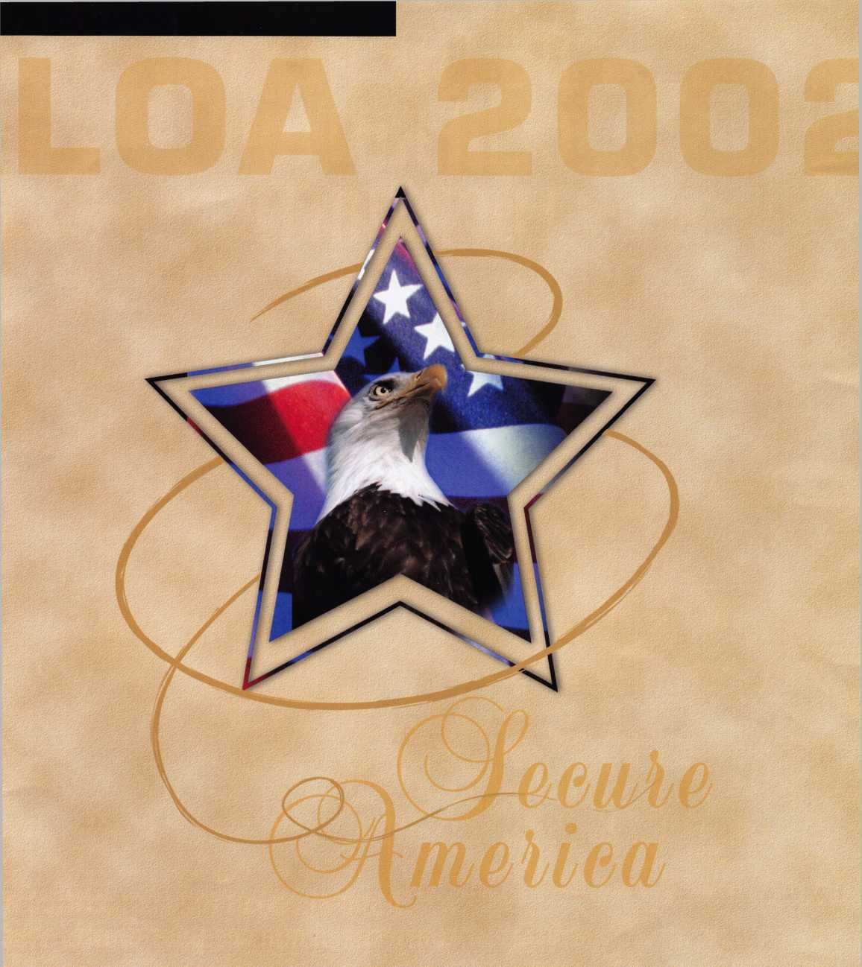

22-28, 2002 • Donald E. Stephens Convention Center • Hyatt Regency O'Hare

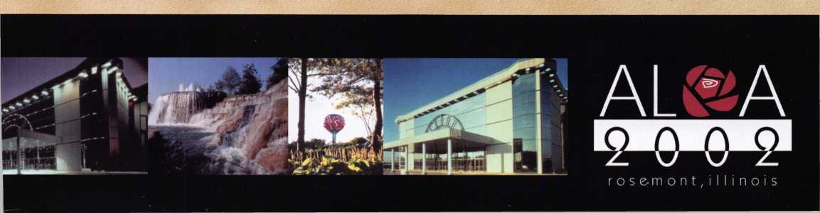

ggj&ill

**" Jump ahead of the competition a warp speed and see your profits soar**

**Hickok’s New Generation STAR transports you with the factory tool for programming keys 1  
Ford-Lincoln-Mercury and Mazda vehicles with passive anti theft systems (PATS).**

**Program vehicle keys through Model Year 2001 with Hickok’s NGS Model 800-8LA-$1995** ^ **Update your existing software-the 2001 Complete New Model Ford Software Update Model 80LA-$i**

800/342-5080

HICKOK

INCORPORATED

wuHu.hickok-ii

